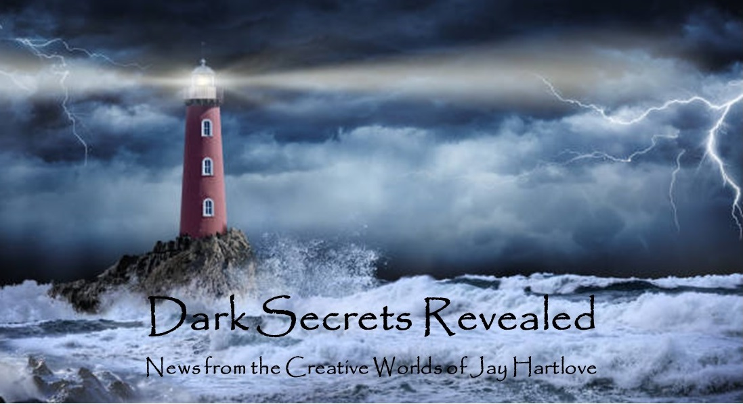
Issue 26 April 2025
Yes, I skipped another month’s edition. With all the political turmoil this year, I have not been able to focus much on my fiction. But that does not mean I haven’t been writing. I have been writing to legislators and having lively conversions online with strangers about how people feel and what we can do about it. In that same vein, this issue will share some of the thoughts I have committed to paper. I’m not here to change anybody’s mind about anything. I like to think that this stuff is constructive.
In my non-fiction life I have decades of training and experience in how money works. I have a Masters of Science in Finance and a legal degree. I have been working in business law and banking for over forty years. That also means I have made my living and my life’s work with words. Whether it has been court filings, contracts, regulatory analyses, or advertising disclosures, I have used the same skills that I employ when I write fiction.
I have been getting rejections from the publishing gatekeepers. My story Ashes was rejected by another magazine. The publisher who had The Dove and Crow also turned it down, albeit with one of the nicest rejection letters I’ve ever seen. He said he liked everything I had done with the book, but the subject matter just did not excite him as much as he would need in order to pitch and champion the book to his boss. Admittedly, a mythic adventure written for adult women who have been scorned in love is going to have a limited audience. I need to read the room better. Back to seeking agents. I am attending a pitch fest in a week. Wish me luck.
I put all the back issues of this newsletter up in an archive on my website www.jaywrites.com. Check them out if you joined late and missed some editions.
I would very much like your feedback on this newsletter. Please feel free to write me at jay.hartlove@gmail.com and let me know your thoughts. This newsletter is for you. I could set it up as a sales tool, with lots of buy links, but that’s not why I write it. I do this to share my work and insights with you.
Also, please let me know what you thought of Goddess Revealed. Did you find it interesting? Did it make you want to go back and read the trilogy? Do you think it is a good incentive to sign up for this newsletter?
Here are the usual newsletter columns:
- What’s Cooking: Previews/discussion of what I am actively working on. Also links to interviews, appearances, and other current writing news.
- Mister Wizard: Advice and analysis to help my fellow writers.
- The Aisle Seat: Recommendations. I am a huge movie fan and watch several every month.
- Have a Drink: Wherein I will share personal stories.

What’s Cooking


Fair Taxation
At the moment, the Republican majority Congress has abdicated its power over federal spending to the Administration. The majority of citizens see this and are not happy with how the Administration is slashing services and robbing federal tax dollars to give them to the already-rich. With various special and midterm elections coming up, the Republicans are likely to lose their majority in at least one of the houses of Congress.
At that point, the Democrats and Independents will need a plan to immediately correct the imbalances that are making working Americans suffer. The Administration has lost sight of the fact that the federal government only exists to provide services that must be supplied across state lines or that are not profitable enough for

private industry to supply. The Administration insists that spending tax dollars on a safety net, like Medicaid, Veterans Benefits, and SNAP, is waste and needs to be cut. That safety net is one of only three reasons people agree to pay federal taxes. The other two are infrastructure and defense. And they are cutting infrastructure as well. Government isn’t supposed to make money like a business. It is there to supply services that the people need. When the Republicans lose their stranglehold on spending, we need a plan to refocus government.
The very rich will use all their money to fight any significant measure that affects their wealth, like raising the tax rates for corporations or the richest individuals. A radical wealth redistribution is unrealistic. Sorry, Bernie. At the same time, the working class is finally seeing their enemy is not the brown or gay man next to them, but the rich man who has rigged the economy. If we can’t take money from the rich and give it to everyone else, then we can tie the two groups together.
High corporate tax rates encourage investment in plant and employees, by lowering the profit that is subject to tax. This is why middle American families could buy a house with one full time worker in the 50s, 60s, and 70s. Lower tax rates take away that incentive and make the tax hit for profit taking less painful. Low tax rates directly encourage price gouging and profit taking. We need to educate, no, we need to hammer that message to the working class if we are going to raise the kind of support we'll need to raise corporate taxes at all.
I propose a middle ground, win-win solution. Raise the tax rates for corporations and the ultra- wealthy, but index that rise against the Consumer Price Index. At current price levels, move the corporate tax rate to 40%, but with the caveat that for every percentage point that the CPI drops, the corporate tax rate also drops the same percentage. Let them have a tax break, but make them lower their prices in order to get it. The rich are going to find a way to get richer. That's their only job. But tying their breaks to consumer prices means the rich will have to strike a balance between profit taking and price fairness. They will make less with lower prices, but they'll be able to keep more of it with lower taxes.
The two checks in classic capitalism are competition and taxing profits. Mergers have eliminated competition. In the absence of balancing competition, we need to strike a new balance directly with consumer prices. Companies will complain that they can't individually lower prices enough to move the broad CPI. But they collude on prices all the time. Let them collude to lower prices so they all get a bigger tax break. Make them work for it.
While we are re-tuning the tax system to bring back fairness, let us address a loophole that the ultra-wealthy use to avoid paying taxes at all. Holders of large, stable stock positions borrow against their collateral, thereby drawing a tax-free income. Raising taxes on upper brackets has no effect if they are avoid taxes entirely. This has to stop. Tax unrealized gains. If a bank believes it’s collateral, then it is valuable and taxable.
An incentive to adopt this plan is to eliminate our current Capital Gains tax. If an asset has gained value by the time you sell it, you will have already paid taxes on the gain. This allows asset sales without tax encumbrance at the time of sale. The timing and details would have to be worked out, like exceptions for primary dwellings, but this should close the gap of the rich living large and tax free by borrowing against their holdings.
By seizing back the power of the purse through taxation, and implementing these two changes, Congress can incent business to lower consumer prices, and eliminate billionaires dodging their taxes. We can’t expect to rebalance the entire economy at one time. The rich have been planning and building the current imbalances for fifty years. But we can make taxes do what they are supposed to do, which is make life more livable for the people who pay them.
While we’re on the topic of whether Congress acts in the people’s best interest, we should put serious limits on the ability of legislators to buy stocks. That will be a big stretch, maybe even bigger than reining in the rich. Far too many Congresspeople are addicted to corrupt money for us to expect them to freely vote against it. Maybe for a later day, but it needs to stay on the agenda.

Mister Wizard

Desperately Seeking Relevance
What’s an artist to do in desperate times? A lot of people who are good with words are using theirs to express outrage. I see a lot of political cartoons and graffiti calling for action. Protest songs are making a comeback. As an older, straight, white, cis male, I only have limited avenues to express my allyship to support my BIPOC and queer friends. I don’t want to take away their microphone, so I watch where I speak up. I donate money and time to causes, including to help throw a Pride parade. Now, with rising fascism openly targeting them, I want to do more. Yes, things will be worse for all of us, but marginalized people will face the brunt of it.
I am, thus far, an indy writer. I have a very small circle of influence. And that circle is shrinking as Meta squeezes my left-leaning exposure down to a handful of you. I wrote a protest story that publishing gatekeepers thought went too far (“Every Little Bit” that I shared here with you last month). People are freaking out, and rightly so. Last month I saw even my small newsletter circulation shrink to only half opened. People are too preoccupied keeping up with the news.

With such small voices, what can we do? Gen AI is about to flood every creative marketplace with junk that will further drown us out. We saw the impact that self-publishing had on the book market, with millions of books filling up seller sites. Get ready for another wave.

Then there is the intrusive thought that work that doesn’t rage against the sky will do nothing to make anything better. How could a romance novel or a still life painting or a break-up song possibly help a world on fire? You find yourself asking, what’s the point?

And that’s where you would be wrong. Your work helps to normalize what should be normal. Television writer Vince Gilligan, in his acceptance speech for the TV Laurel Award this year, said he wants to see his fellow writers create more stalwart good guys. He said that writing Hannibal Lecter or Darth Vader is fun, but who knew these characters who were intended to be cautionary, would turn out to be inspirational. He called for more humble, thoughtful heroes that audiences could model instead.

I know it’s hard to summon creativity when you’re surrounded by bad news. Take heart. Know that everything you create, no matter how few people see it, will remind those people what normal is supposed to look like, and what they should be fighting for.

The Aisle Seat
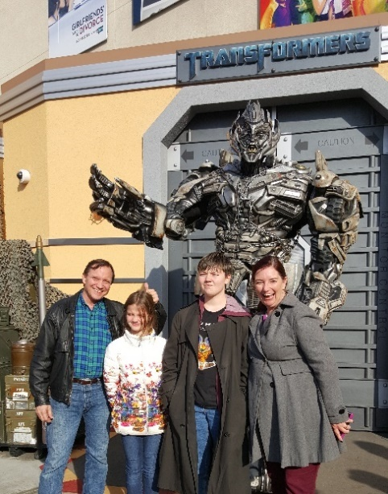
Rollerball 1975
This month I watched or re-watched three Science Fiction films that question the accepted norm.
Science Fiction films in the 1970’s gave us some great cautionary tales. Soylent Green and Rollerball are two of my favorites. My anarchist 19-year old was over for dinner and I had fun sharing one of the great stick-it-to-the-man stories of my youth. Be sure to watch the 1975 version. The 2002 remake completely misses the point of the story. Bad movie, no biscuit.
James Caan plays Jonathan E, a champion player in an extremely violent game designed to show the futility of individual effort. The

world is run by corporations that took over when countries failed. The only way to get ahead is to participate in corporate power hierarchies. But Jonathan stands out. Fans worldwide adore him. He is a threat to corporate control. Caan does a marvelous job playing a man who is not bright enough to understand why he is a threat. He is after all a ball player. But he knows the game better than anyone. And he knows when he is being backed into a corner. Highly recommended for anyone who needs to see an individual win against the establishment.

Companion
Writer/Director Drew Hancock crafts a hilarious version of Ex Machina drawing on the excellent comedy talents of Sophie Thatcher and Jack Quaid. Thatcher has been in multiple films in the last year, including Heretic, Maxxie, and the television series Yellowjackets. Here she gets to shine. Iris is a pleasure android that is programmed to not know she is artificial. This creates a narrative that plays with her point of view and draws the audience into her predicament. Jack Quaid, who is also doing well this year with films like Novocaine, plays a nerd who is in over his head. Not to give too much away, but he and his friends have in mind to set up Iris to take the blame for a crime. As she becomes aware of both her artificiality and the conspiracy, she seizes the opportunity to turn the tables. Watching a slave take command is always gratifying. Great set up mixed with great dialogue and great comedic timing makes this film so much better than I expected. Twisted and unpredictable. Great fun.

The Substance
Writer/Director Coralie Fargeat attacks vanity and youth culture with both barrels blazing in this graphic horror examination of how we maintain self-esteem. Demi Moore plays an aging actress whose only real success has been a long-running fitness series that is, of course, focused on youthful vitality. When her slimeball producer threatens to replace her, she resorts to an experimental drug to regain her youth. But that’s not how the drug works. The miracle cure is much more complicated and dangerous than she expects. She ends up in a battle with her youthful alter ego, both figuratively and literally, which pushes consequences from bad to worse to oh-shit-you’ve-got-to-be-kidding. Like so many horror stories, our heroine would have done so much better if she had a good therapist to steer her back from the edge. The lesson: despite all the advertising around us, do not try to hold onto youth. It’s not worth it. Diversify your options and be willing to grow old gracefully. Awesome practical makeup effects won the Oscar. Yikes.

Have a Drink

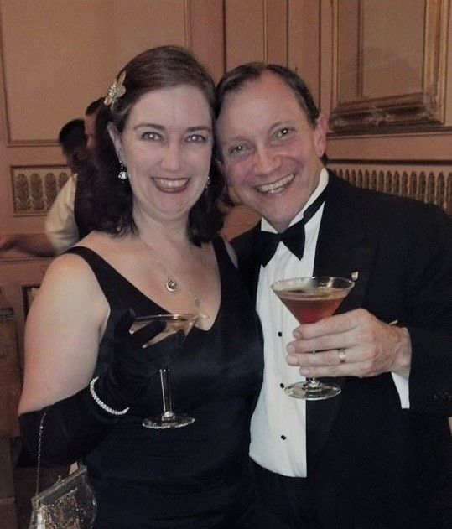
Adventures in Foam Latex

Speaking of practical makeup effects, this month I invite you to come along as I reminisce on costumes I have made that relied on casting foam latex. Back in 1988 I was inspired to learn how to use these materials when Star Trek - The Search for Spock introduced Klingons with the bone ridges. I was regularly competing costumes at conventions at that time, and CostumeCon 6 was coming to Northern California where I lived. One of the features of CostumeCon was the Future Fashion Folio and Show. (I say “was” because after 42 CostumeCons, the convention is taking a hiatus. I will let you know if and when it starts up again.) Ahead of the convention, designers would draw up proposed costumes around a

theme. The event organizers selected the best designs and published them in a folio to all the paid attendees. People then agreed to create the designs for the show held at the convention, with the designer getting first dibs. The show usually ended with a wedding couple. My then wife and I did a Klingon wedding, based on the Fifteenth Century Spanish silhouettes of the film’s costumes.

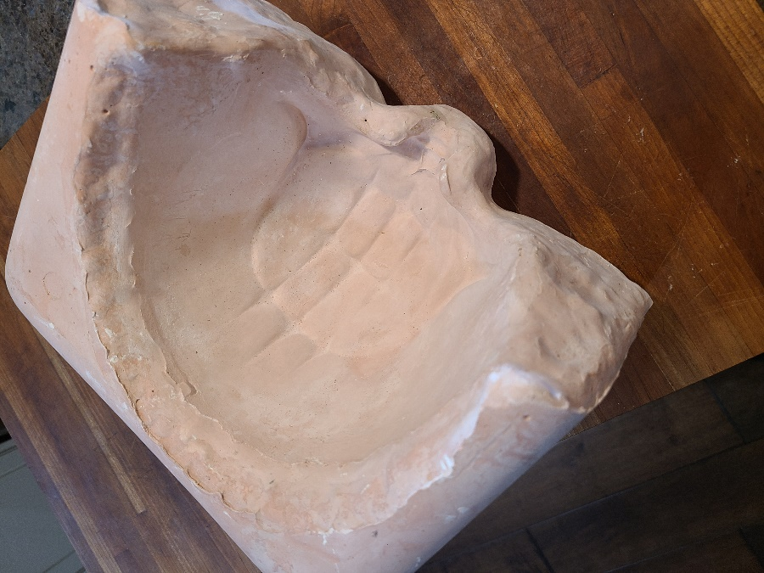

Foam latex casting is a time-consuming, multi-step process, but it is still the best way to create this kind of makeup appliance. 3D printing and modern moldable materials have greatly simplified cosplay and made it easier for enthusiasts to produce extraordinary work, but nothing has replaced foam latex for changing facial features. What follows is a very high-level summary of the steps to making the rubber makeup appliances.

The process starts with a life cast of the original subject, like a person’s face. You coat the subject with an impression material called Alginate. This is the same material dentists use to make impressions of teeth. Once this sets you wrap the whole face with quick-setting plater bandages that hold the Alginate from flexing. You pull that off the subject, flip it over, and fill it with a very hard form of plaster called Dental Stone. Again, we borrow these materials from dentistry. This “life cast” will be the basis for all your sculpting.

You use oil-based clay to sculpt the new surface you want in order to change your appearance. You coat this with mold release, flip it over, and plunge it into more Dental Stone. When that hardens, you pull the life mask out and clean off the oil clay. When you place the mask back in the mold, the empty space is the shape of your new appliance. The picture above is the negative mold for the Klingon makeup shown above.

You make the appliance by mixing foam latex, placing it in the negative mold, and pressing the mask into it. Remember to coat both molds with mold release. You bake the assembly until the rubber vulcanizes and solidifies. When you pull the molds apart, you are left with little rubber toys that you can glue to your face to change your appearance.

With the success of the Klingon makeup, I started using foam latex more and more. In 1990 at CostumeCon 8, I put my understanding of molds to the test with my re-creation of The Abominable Dr. Phibes, from the 1971 movie of the same name. In the film, Vincent Price plays a burn victim who uses appliances to reconstruct how he appeared before the accident.

First, I had to make the burn victim. His jaw is fused together. In the film, he is an inventor who has devised a way of using microphones to speak. It is set in the 1920s, so this would have been quite ingenious for the time. I sculpted clay over my life mask to make space for my jaw to move. I them molded heat-formable plastic over that built-up face to form the fused skull-like face. I then used the Alginate/bandage/Dental Stone technique I described above using the plastic burn victim face as the base subject.

Once I had a Dental Stone version of the burn victim, I used the oil clay to sculpt Vincent Price’s face. I then made a Dental Stone negative mold of that face. I pulled them apart and cleaned off the clay. Then I made a foam latex appliance that was the burn victim face on the inside and Vincent Price’s face on the outside.

I installed a microphone inside the plastic burn victim face. I made it with jaw room so I could speak inside the mask. The microphone ran to a jack at my neck, with hand held speaker that mimicked the gramophone used in the film.

One stage, I came out looking like Vincent Price, then pulled the rubber mask off to show the burn victim, duplicating the climax of the movie. Yes, this was a tremendous amount of work. But it was totally worth it. If you haven’t already, go see the movie. It’s awesome.

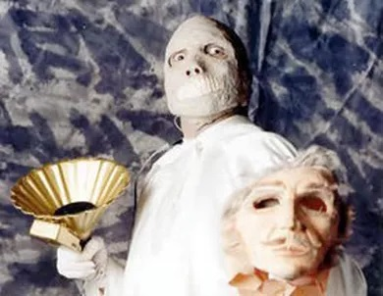

After seeing what I could do with large-scale makeup effects, I wanted to explore the more subtle effects of really thin appliances. I sculpted eyebrow ridges, cheekbones, and ear tips to create a vampire. With my face relaxed, the appliances did not change my appearance very much. But when I grimaced menacingly, the appliances remained slightly more rigid than my face, which raised them and transformed me into a much more animalistic creature.

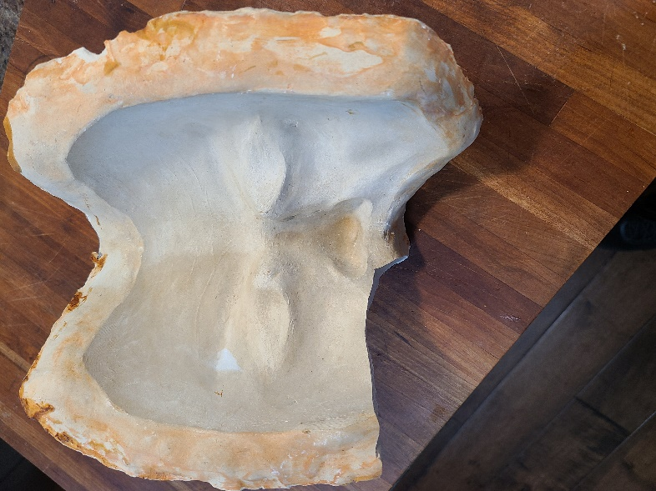

At some point my fellow costumers started approaching me to share the techniques. I was actively organizing and teaching classes with the Greater Bay Area Costumers Guild, so I held a hands-on seminar for how to make elf ears. An ear is much smaller than a whole face, and so the process was easier to demonstrate. We had a dozen folks and everyone went home with finished appliances.

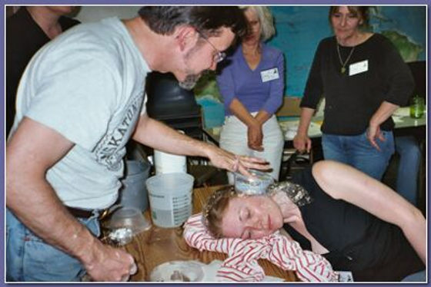

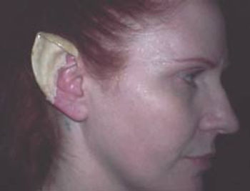

That’s it for this edition. I hope you enjoyed it. Please invite your friends to sign up. I am actively generating content as I never have before. This newsletter is the best place, and in some cases the only place, to hear about it all ahead of publication.

Until next month, be well!

