From The Chosen

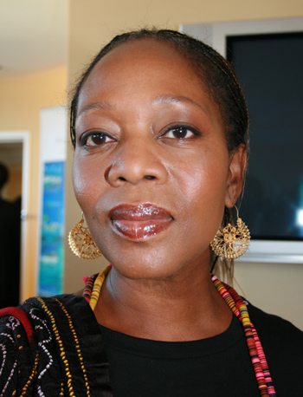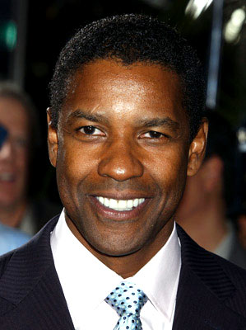
Alfre Woodard as Dr. Sanantha Mauwad Denzel Washington as Charles Redmond

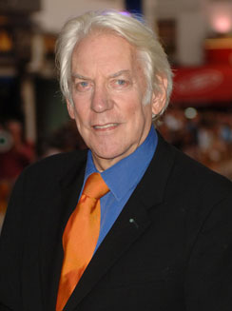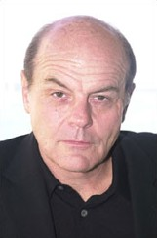
Donald Sutherland as Silas Alverado Michael Ironsides as Joseph

From Daughter Cell

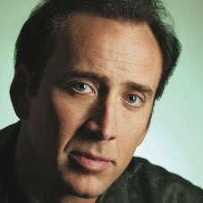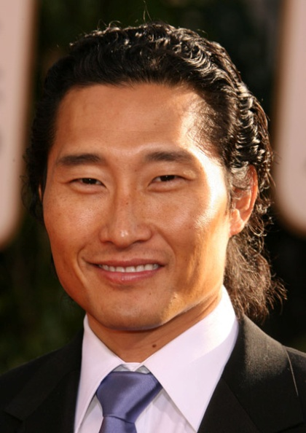
Nicolas Cage as Dr. Randolph Macklin Daniel Dae Kim as Young Nae Yoon

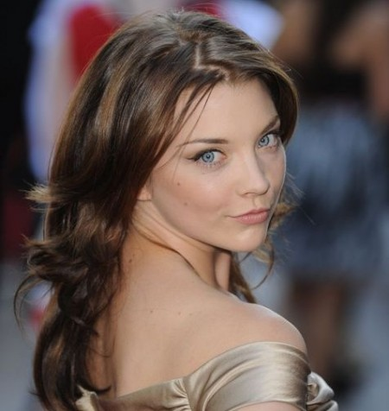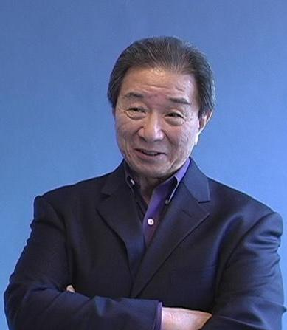
Natalie Dormer as Desiree Macklin Randall Duk Kim as Lo Cheung

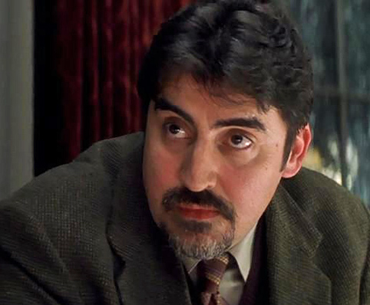
Alfred Molina as Simon Herrera
From Isis Rising
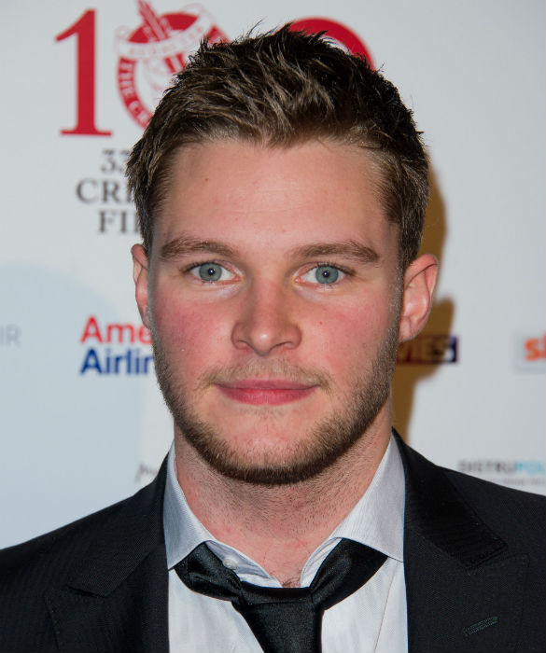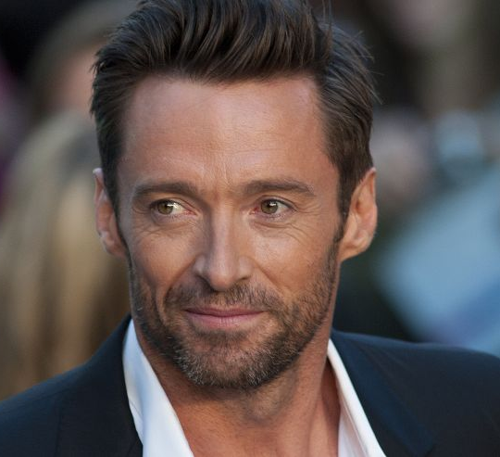
Jack Reynor as Alec Doogan Hugh Jackman as Benito Nomini

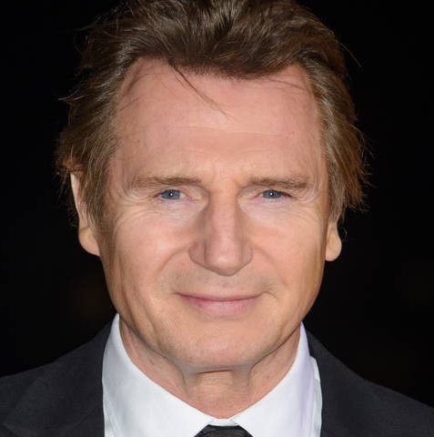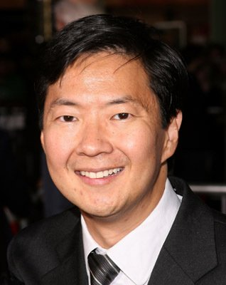
Liam Neeson as Michael Archibald Ken Jeong as Renpo

