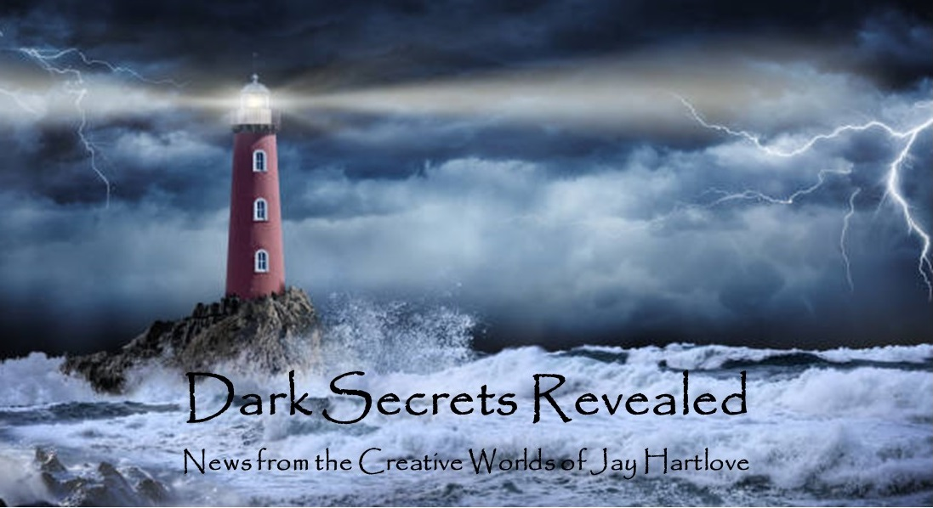
Issue 28 July 2025
Today is the last day of July. Today I turn 68. That does not seem possible. On the other hand, I do have evidence of the time that has passed. I spent my 20s learning performance art, my 30s finishing my formal education, my 40s starting a family, my 50s getting serious about my career, and so far my 60s have been a creative heyday. That’s a lot of water under the bridge. I’m counting on that water to keep carrying me forward.
In this edition I talk about finding your creative enthusiasm and being open to inspiration. As usual, my examples are all from my own experience. Your mileage may vary. I like staying busy to avoid thinking about the delays and frustrations that come from working in the real world, with its gatekeepers and budgets. No, I have not heard back from the publisher who is reviewing The Dove and the Crow. Fingers remain tightly crossed. It is a challenge to type like that.
I put all the back issues of this newsletter up in an archive on my website www.jaywrites.com. Check them out if you joined late and missed some editions.
I would very much like your feedback on this newsletter. Please feel free to write me at jay.hartlove@gmail.com and let me know your thoughts. This newsletter is for you. I could set it up as a sales tool, with lots of buy links, but that’s not why I write it. I do this to share my work and insights with you.
Also, please let me know what you thought of Goddess Revealed. Did you find it interesting? Did it make you want to go back and read the trilogy? Do you think it is a good incentive to sign up for this newsletter?
Here are the usual newsletter columns:
- What’s Cooking: Previews/discussion of what I am actively working on. Also links to interviews, appearances, and other current writing news.
- Mister Wizard: Advice and analysis to help my fellow writers.
- The Aisle Seat: Recommendations. I am a huge movie fan and watch several every month.
- Have a Drink: Wherein I will share personal stories.

What’s Cooking



Finding My Mojo
From January to June I was barely able to open the laptop. I was overwhelmed by doubting the value of writing fiction while the world burns. Yes, I told you about the screenwriter who said in an acceptance speech that it is important to keep showing the audience what normal is supposed to look like, what is worth fighting for. Even with this quote on my side, I ended up skipping two issues of this newsletter and made very little progress on Sins of the Father.
What I needed was something concrete to get excited about. Last weekend I attended BayCon, the oldest running science fiction convention in the San Francisco Bay Area. I usually sign up to speak on panels, help with the masquerade, or otherwise make

myself a useful member of this community. This time I only signed up as a coach for the writers’ workshop. (A big Thank You to Dr. Wanda Kurtcu for reviving this event.) I didn’t even spend time manning my publisher’s table. I had lots to do on Independence Day weekend, so I only went to the con for one day. I went to hang out with friends I rarely see in person. Turns out they had treasures to share.
I spent a two-hour lunch talking with J. Malcolm Stewart about the art of writing trilogies and exploring literary themes while telling ripping yarns. He is both a journalist and a novelist. You should look up his work. He just released Look Back in Horror 2, which is his second collection of essays on classic monsters. He published his novel The Eyes of the Stars as part of a trilogy but the publisher folded after the first publication. This sounds very much like what happened to me with the Goddess Chosen series. Except it was worse for Jason. The Eyes of the Stars is Book Two. He has a prequel and a sequel. Revving up the enthusiasm to finish and pitch Books One and Three to complete the trilogy has been daunting. He pitched them to me, and they sound great. But that’s going to be a lot work.
I then spent a two-hour dinner with Cliff Winnig talking about the dystopia that the technology oligarchs have planned for us. He once attended a Transhumanist conference where science fiction author Vernor Vinge was speaking. He went to meet Vinge, who coined term Singularity for that point when artificial intelligence surpasses human intelligence. Vinge borrowed the term from physics where it means the unknown center of a black hole. We cannot tell what happens at the center except to postulate that matter becomes infinitely dense and time stops. Similarly, we cannot predict what will happen when computers pass us. It could be good, it could be bad, we can’t tell. Cliff came away from the conference somewhat horrified by what the attendees wanted to hear. Transhumanism looks forward to immortality through technological enhancement, especially the integration of the human mind into a computer. He said the attendees were very clear they wanted to hear how they could personally gain from this as soon as possible, regardless of consequences to society. This is supported by speeches from tech bros like Peter Thiel and Curtis Yarvin who want a technological feudalism where capitalism dissolves into tech empires where only the rich owners make all the decisions for the workers who make up the rest of mankind. Look up Urbit.
Then I remembered my story The Price. I wrote the treatment for this book decades ago, but put it down with doubts about my telling a story about slavery. The premise is that in the far-flung future, subservient androids help with everything, and people assume their AI was developed as any other software over time. Our hero discovers this is not true, that androids have their sentience because they are imbedded with souls stolen from criminals and war victims. The cover blurb reads:
A prince discovers the lie behind his space faring civilization’s success and gives up his life of luxury to expose the truth. The wealthy and powerful will do anything to stop him. Thus begins the saga of Cedrick Ali Khan, who fights and steals his way across the galaxy to find the core of the greatest conspiracy ever perpetrated. His only allies are the expendable androids who see him as their savior, for it is the secret behind their very existence he is trying to reveal.
Many years later I found I could tell a slavery story if I slipped it into a fantasy romance. This was of course Mermaid Steel. With that book in print, The Price was pushed even further back on the shelf.
Until now. The Price isn’t about slavery as much as it is about the destructive selfish vision of people who are willing to upend society to gain their transhuman dominance. Yes, Thiel and Yarvin will be called out in the book. Now I’ve got something to sink my ire into. I will keep you posted here on progress.

Mister Wizard

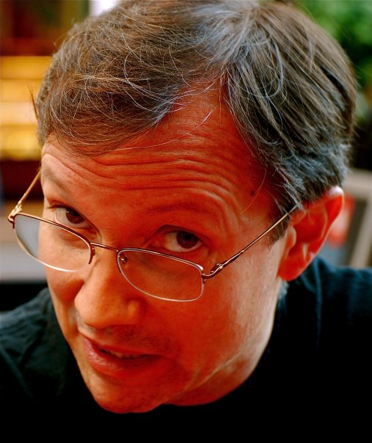
Keep Listening
I’ve talked here about how I jot down story ideas and expand upon them if they feel like they might be worth investing creative time. This means at any one time I typically have a dozen buckets waiting for me to throw more scraps into. The scraps are usually bits of information or insight that cross the path of my daily life. Here are some examples from just this last month.
A conversation with an old friend about the good old days of tabletop RPGs gave me an insight that allowed me to revive an idea for a game I had toyed with 40 years ago at a gaming convention. The key clicked, and I now have a new card game ready for playtesting. It is called, “Derring Do – The Game of Death-Defying Spectacle.” It pits players to design the most dangerous and outrageous public stunts. It feels good to bring the game to life after being stuck on the shelf for so long.
I mentioned above the conversation I had with Cliff about Transhumanism. Well, a few nights later I was chatting over dinner with my younger brother who is a tech executive at Meta. Turns out Mark Zuckerberg’s current shiny thing is solving machine self-awareness. Machines learn by carpet-bombing a problem with every possible solution until one works. Humans, on the other hand, make an attempt, and if it fails, they look at the failure and ask why it failed. They find a solution in many fewer tries than a computer because they learn from their mistakes. Computers are still faster because they can try a million times in the same time it takes a human to try twice. If a computer could learn from its mistakes like people do, it would not need the million tries. Not only would this be faster, but learning from your mistakes turns out to be a key component of self-awareness. It requires that you put yourself in the picture. This is exactly the concept I am playing with in The Price. This has added even more fuel to my enthusiasm for the book.
My wife and I went to see Lady Gaga on her Mayhem Tour. Some bands write concept albums that tell a story. The concerts of those albums guide the audience through the story. Lady Gaga writes pop songs. Her albums may have a theme, but they are not storytelling albums like, say, the albums of My Chemical Romance. With many albums and many hit songs, she has a lot to work with. For this tour she has strung together two and a half hours of her songs into a “jukebox” musical that tells the story of a war between the red and white queens in Alice in Wonderland. The gothic imagery and Broadway staging harkened to The Phantom of the Opera. She even had a gondola through catacombs. Sorting her songs and pulling them together to tell a story reminded me of my current work on The Two Flowers. When I wrote The Mirror’s Revenge, I had musical themes repeat throughout the play to tie the scenes together. After seeing how the story pulled the songs together in Lady Gaga’s concert, maybe I can have more elbow room to write more impactful songs without trying to make them all sound like they belong together. Definitely food for thought. But I wouldn’t have thought of this without seeing it done first.
My point is, pay attention to what is around you. Confirmation bias is often denigrated as bad logic, but our brains use it whether we know it or not. Use it to your advantage. If you have “idea buckets” hungrily waiting for more material, then let your brain sort through your daily experiences and cherry-pick the “good stuff” that fits in one of your buckets. Never stop listening. Anything could be research for one of your stories.

The Aisle Seat
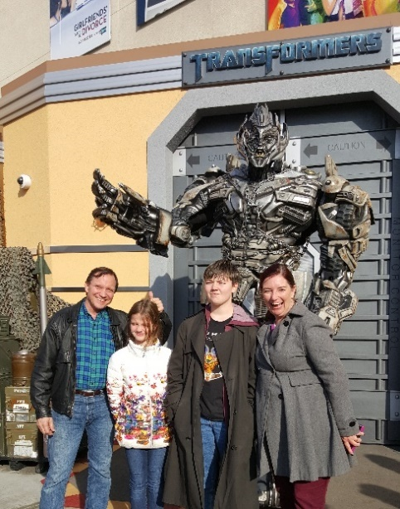
The Accountant 2
This month I am reviewing three spy/assassin thrillers that came out this year. When I tell people I write thrillers, this is the sub-genre most folks think of. Weirdly, it is one of the varieties of thriller I have not written. My thrillers have been supernatural, medical, and science fiction. Maybe someday.
The first Accountant is an excellent movie. I reviewed it when it came out a couple of years ago. This sequel spends almost no time explaining the characters and the set up that were developed in the first film. Is that a flaw? Not necessarily. I don’t count it against this one. We rejoin Ben Affleck’s autistic genius assassin Christian Wolff some months after the first film ends. The government investigator Ray King from the first film, played by the always wonderful J.K. Simmons, is killed working on a human trafficking

case involving a Mexican family. A mysterious assassin named Anais is involved, but no one can figure out who she is. A new investigator named MaryBeth Medina picks up the case. King wrote “call the accountant” on his arm as he died. Medina contacts Wolff, who then brings in his brother, who is also an assassin. If this sounds convoluted, it is. There are some unlikely turns, but it’s a fun story with a really nice twist at the start of the third act. You do need to pay attention to keep up with all the story threads. The fun in the film is watching bad guys do good.

The Amateur
Rami Malek plays a CIA analyst whose wife is killed in a terrorist attack. When his bosses won’t pursue the matter, he insists he can help, given his considerable data wrangling abilities. His bosses say they don’t want to capture the terrorists because they are tracking them to bigger criminals. Our analyst is not convinced. He manages to connect with a battle-tested spy played by Laurence Fishburne. After some basic training, he escapes Fishburne’s oversight and heads off to avenge his wife. He pulls off some very clever killings. The real reason his bosses don’t want to pursue the terrorists is supposed to be a shocking surprise, but it isn’t (at least not to this jaded thriller writer). All the fun in this film comes from watching a nobody succeed in bloody, sometime fascinating revenge. Bring lots of popcorn.

Drop
This one tries really hard to be clever, and it succeeds in part. A widowed mother goes on her first date in years with an entirely charming photographer, but the date is ruined when she keeps getting threatening text messages “dropped” on her phone. The tension builds until the texter finally tells her to kill her date. Her date has taken some incriminating photos and the texter is an assassin hired to eliminate him. The high-end restaurant becomes her prison as the cat and mouse game plays out. She knows the texter is in the restaurant because of the way the drop tech works. But who is it, and how can she win? Things escalate nicely, including home security footage of her child at risk at home. I thought the texting and the dialogue and the action kind of ran over each other in places, and there were a couple of logical flaws, probably due to editing mistakes. All in all it’s a pretty good puzzle.

Have a Drink

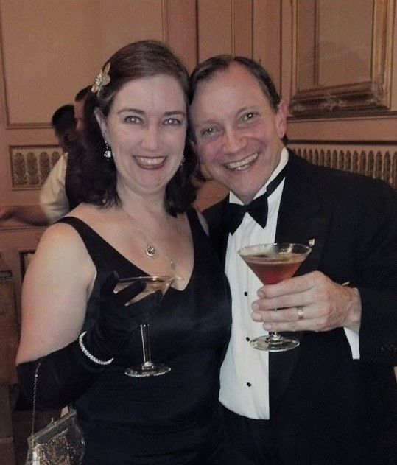
The Two Flowers – An Opera of Ancient Atlantis – Act 2

Last month I shared the first Act of my new opera The Two Flowers set in ancient Atlantis. If you missed it, I post all my newsletters on my website www.jaywrites,com.

The first Act ends with the high priests of the two warring city-states realizing the situation is far worse than they thought, that the two newly ascended regents do not even recognize each other even though they grew up together during more peaceful times.

Here is Act Two.

ACT TWO
INTRODUCTION
Archeologist quartet points out that the gods have lied to each other, and the priests' plot depends on deceiving the servants, the regents and the gods. The chorus asks, when webs of deception begin to unravel, who can rise above and still do the right thing? Can we still have faith in the healing power of love?

SCENE ONE: The magic garden
The servants again are turned around in a mysterious fog, and they meet again in the magic garden. They admit that when they each saw the fog they hoped to bump into each other. Again they dance around one another, this time much closer than before. They both stopped to gather flowers as gifts. They both comment on how they have looked for each other at court but have had no luck. They agree that it must be that court is so big, and how lucky they are to cross paths in this garden. Their song is built around, “Thank my luck.” By now they are quite smitten. They agree to meet again the next night.

SCENE TWO: Chaluna’s bed chamber
While Chaluna sleeps, her dream plays out with children actors portraying her and a young Prince Torron playing. Their fathers stand by together watching proudly. The music plays the melody as instrumental until she awakes, confused. This is her big solo. She sings she has the dream often, that it’s as if she lived a different life when she was young, but now she can’t “sort memories from dreams.”

SCENE THREE: Mountaintop overlooking the valley
Belacor is watching the valley when Shimissa descends on him furious. She has visited Ygnatim’s tomb again and discovered Belacor's anti-resurrection curse -- and therefore that he broke his promise not to meddle. Their song and Flamenco style dance is built around “How dare you.” He counter-accuses her of meddling with the crown, since he knows the son took it off the father's head. He says he only cursed Ygnatim because he knew she owned a crown of resurrection, and that she'd use it. This argument gets very personal and very dirty very quickly. The two step back up into the sky and start hurling lightning bolts at one another.

SCENE FOUR: A garden in Kirolos at night
Zupi is waiting for Pamo in a garden near her palace (but not the secret garden), but he doesn't come. She has the flowers he gave her. Chaluna comes in and asks if she is waiting for the mysterious young man Zupi has been asking after in court. The song plays like a love song, since it is about love and trust. Chaluna says Zupi shouldn't have pinned such hopes on Pamo (the theme of this song). After all, he gave her pink flowers which only means friendship. If he had given her white flowers it would have meant love. Zupi says she gave Pamo white flowers.
The handmaiden asks if they are going to war. The princess says yes, that she just came from speaking with Riacco the high priest who says it is up to Chaluna to overcome the family hatred. She is willing to, but from what was said at their meeting, she doesn't think Prince Torron is. She too had pinned too high hopes on a man who let her down.

SCENE FIVE: Temple of Shimissa in Thrame at night
The next two scenes are one continuous song that tracks Lacca’s fall into despair as her plans and all hope of avoiding war disintegrate. It is a tortured song punctuated by wailing sequences.
While a storm rages overhead, Torron seeks counsel from Shimissa at the goddess’ temple, but she doesn't answer. Lacca, the High Priestess, tells him Shimissa is now at war with Belacor, and their only hope is if the two regents can rise above their family hatreds and find solutions to their problems. Torron says he's willing to do this, but he doesn't think Chaluna is. Lacca says she's sure Chaluna has the same reservations about Torron, and that she and her high priest are probably having the same conversation. Their song is built around, “Probably just like us.” Torron leaves the temple.

SCENE SIX: Continuing at the Temple in Thrame
Pamo wonders into the temple, moping about dejected, Zupi's white flowers in hand, when he encounters Lacca, the High Priestess. Pamo waited all night for Zupi, but she never showed up. And to make things worse, Pamo just found out that white flowers only mean friendship, unlike the pink flowers of love that he gave to Zupi. The song is the same melody as the previous scene, and centers on “What did I do wrong?” The priestess didn't know the two servants had planned on seeing each other again that night, so she and her cohort hadn't prepared the magic garden. The priestess also didn't know the servants had exchanged flowers, and now she sees the whole plan unraveling. Lacca starts stomping around raving about these miscalculations, cultural differences and flower color when Pamo demands an explanation. Lacca tells him that in Kirolos the pink and white flower meanings are reversed from what they are in Thrame. Pamo doesn't understand why that should matter. Thinking this is her last chance, the priestess goes for broke and tells Pamo that Zupi does love him. She sings of the magical deception, and that Zupi is actually from Kirolos, and that her flowers therefore meant love. Pamo is horrified that Lacca has been conspiring with the enemy, and he leaves in a rush. Lacca sings that she has fallen into the same trap as her goddess by meddling and only making things worse. Again, “What did I do wrong?” The priestess, and the audience, is left thinking all is lost.

SCENE CHANGE INTERLUDE
Archeologist quartet sings that all appears lost. The web of lies, shared by men and gods alike, has unraveled. Usually truth should bring good things, but now the truth seems pointed straight at war. Can love survive to overcome such strong winds of destruction?

SCENE SEVEN: Battlefield
This is the third and last time the main theme melody appears. As the armies ready to clash, the two regents and their generals, up in their boxes, sing about how neither one wants this war, but since the other side insists, they are going to throw in their all, to “rise above.” This is the first musical layer of three.
Behind this song, the warriors chant to work up their courage. The warriors attack. Big choreographed stylized battle scene ensues. Again, the soldiers keep their back beat with clapping and slapping weapons.
Pamo is on the sidelines singing to the white flowers, pining for Zupi. He decides that it doesn't matter that she is from the wrong city. On the opposite end of the stage and not seeing Pamo, Zupi is singing the other half of the duet, singing to Pamo's pink flowers, wherein she makes the same decision. Their song is the final layer of the three-phase song. They sing that they can “rise above” their differences.
The servants spot one another across the battlefield, and make their way around the battle, down stage center, singing they know they will be killed if they are found, but they will again, “rise above.” This song starts quiet but develops a celebration of their courage like “I choose you,” by Sara Bareilles. They fall into a loving embrace. The moment they kiss…
Back out above the battlefield the priests' spell works. Torron and Chaluna spot one another across their clashing armies and are magically moved to have the big change of heart. Both regents have been wearing large ceremonial metallic necklaces throughout the play. These break and fall noisily to the ground. The music stops and everyone looks.
The melody shifts to the upbeat, triumphant section we have been waiting for, picking up the celebration from Pomo and Zupi’s song. The regents sing about rising above lies and hatred from opposite sides of the stage, they wade though the ranks, which stops the fighting, They meet mid-field where they clasp hands. They recognize each other as childhood friends, realize what their fathers had done to keep them apart, call a truce, and embrace.
The generals pick up the song and praise their leaders for rising above the hatred that consumed their fathers. (By now it should be clear the kings’ spell is a metaphor for raising your children in ignorance.)
The gods see this and descend to the battlefield. If their people can rise above their differences, then so can they. The priests meet up and celebrate the success of their plan. The gods admit there is no way they will ever stop meddling, so they agree instead to consult with each other when they do. The priests shake their heads and roll their eyes, singing that they will remain vigilant.
All join in for a final chorus of the song the generals started about rising above hatred.
FIN

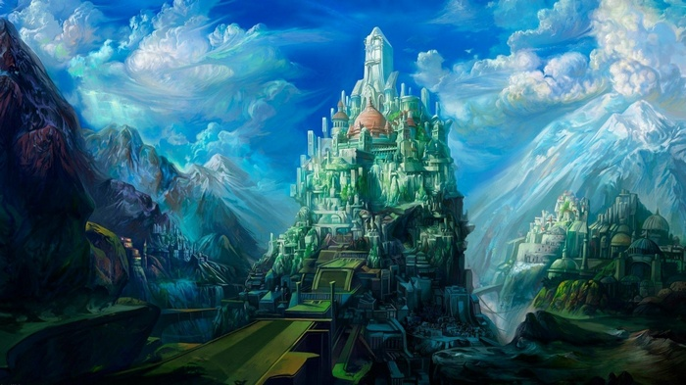

That’s it for this edition. I hope you enjoyed it. Please invite your friends to sign up. I am actively generating content as I never have before. This newsletter is the best place, and in some cases the only place, to hear about it all ahead of publication.

Until next issue, be well!

