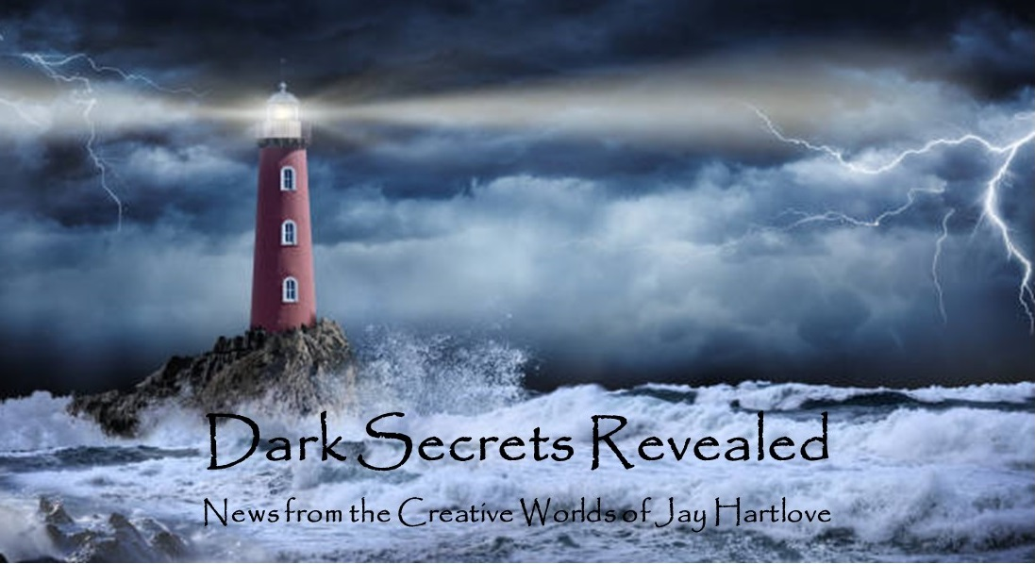
Issue 30 March 2026
I’m back! Yes, the last issue of this newsletter was in September. I apologize for the disappearance. I hope you missed me.
First off, I have huge news. The Dove and the Crow has been purchased! The details are next below.
I have been very busy with life things as well as writing things. The world is going to Hell in the handbasket we feared. A lot of people are saying things I want to say and saying them better than I can. I don’t want to poison this creative space with politics. If I do lapse into commentary, I will keep my comments to how the world is affecting art.
To that end, below you will find an article about the challenge of writing science fiction in a rapidly changing world. I will be attending Baycon (San Jose) in July and WorldCon (Los Angeles) in August. I am hoping to talk about this topic, and others, on panels at those shows.
I put all the back issues of this newsletter up in an archive on my website www.jaywrites.com. Check them out if you joined late and missed some editions.
I would very much like your feedback on this newsletter. Please feel free to write me at jay.hartlove@gmail.com and let me know your thoughts. This newsletter is for you. I could set it up as a sales tool, with lots of buy links, but that’s not why I write it. I do this to share my work and insights with you.
Also, please let me know what you thought of Goddess Revealed. Did you find it interesting? Did it make you want to go back and read the trilogy? Do you think it is a good incentive to sign up for this newsletter?
Here are the usual newsletter columns:
- What’s Cooking: Previews/discussion of what I am actively working on. Also links to interviews, appearances, and other current writing news.
- Mister Wizard: Advice and analysis to help my fellow writers.
- The Aisle Seat: Recommendations. I am a huge movie fan and watch several every month.
- Have a Drink: Wherein I will share personal stories.

What’s Cooking

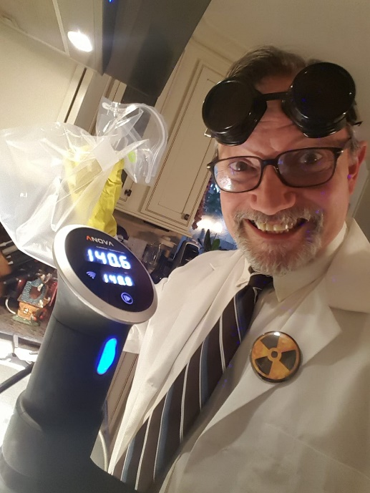
The Dove and the Crow has been bought!
A one-hundred year old small press in London purchased the publication rights for The Dove and the Crow. I cannot mention their name until they announce the acquisition. Due to production and release calendars, they will be announcing in April. The cover will be released in the fall, and the book should be out in May 2027.
My homework for the last month has been to gather audience feedback for fine tuning before we go into line editing and production. I had the book formatted for E-readers and sent it to my favorite beta readers. They all took the assignment seriously and got back to me with thoughtful, and remarkably varied feedback. My sincere thanks to Lillian Csernica, Jason Malcolm Stewart, Valerie Estelle Frankel, Candy Lowe, Mike Van Pelt, Sandra Saidak, Aleks V. Haecky, and Edward Muller. They are also writers. Please go buy their books.
Some of the reviewers are romance writers, some are fantasy fans, some science fiction fans, and one language expert. Since this story includes all of these elements, you can see how useful their advice was. It seems that in an effort to include all the worldbuilding details of a high fantasy novel, I overwrote the text. There were too many talking heads sessions and not enough tension where it should be. I missed several opportunities which have now been caught. This was clearly a case of being too close to the trees to see the forest.
It has been said that the second draft is where you make the book sound like you knew what you were trying to say all along. The book this reader group saw was draft number three. I had rewritten the book based on input from my independent editor and my intake editor at the publisher. This story juggles two main story conflicts: Willa saving the world and Naomi saving Willa. It is a subtle balancing act. I can confidently say, this final draft strikes the right balance. It seems the fourth round is the charm.
I am now at that magical place where every time I think of some change I want to make, I open the book to that section and see that what I have already works better without the new change. I call that DONE. I am handing it in to the publisher.
My publisher has some great ideas for the cover. There will be a lot of market research to land the cover in the right place on the very competitive fantasy book shelf. This image below won’t be the front cover. My twenty-year-old Max painted this watercolor as inspiration. My publisher is considering it as a back cover. The paleness of the watercolor should look good under printed words.
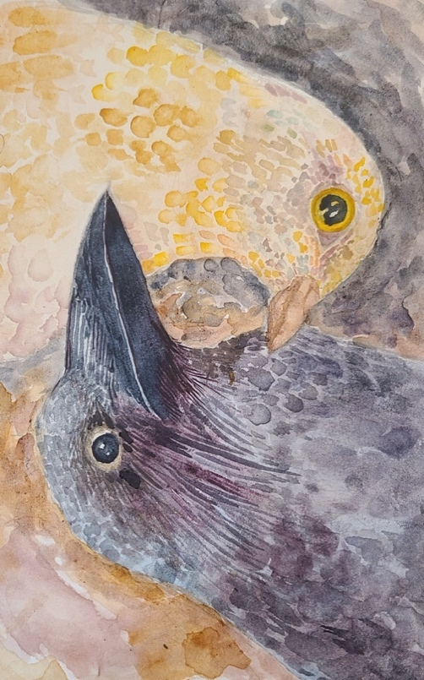
I have made great progress on the sequel Sins of the Father. The first draft is done at 250 pages. I had a lot of ground to cover in this story. I know I did not give in-depth descriptions as I figured out the plot and characters. It is currently under-written. Ironically, this is the opposite problem I had with the Dove and the Crow. This story picks up immediately after the first book and explores consequences. I get to share a lot more worldbuilding as the adventure takes our heroines into mountains, across deserts, and even to the Land of the Dead. I am having fun, which hopefully makes it to you via the page. Here are some teaser images.
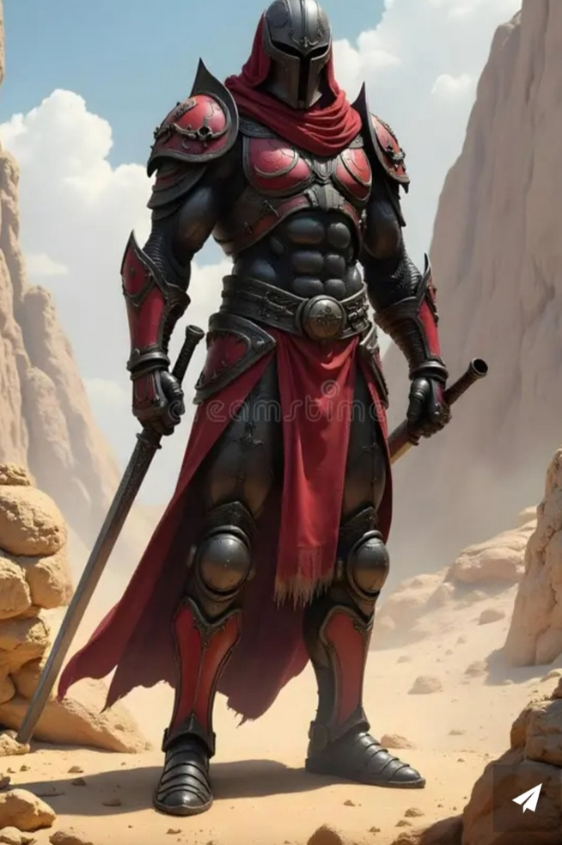

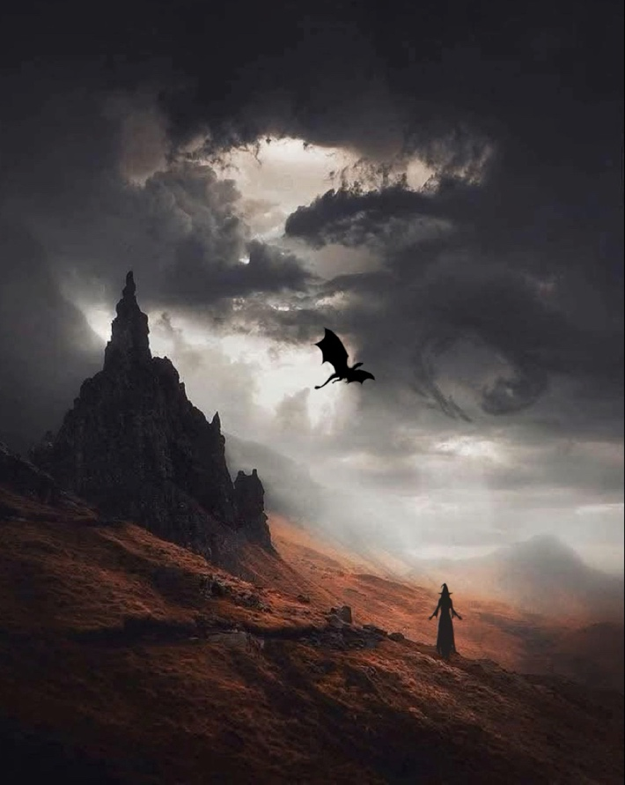

Mister Wizard

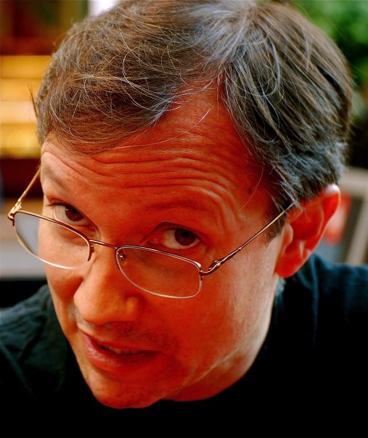
Keeping Up with the Real World
Science fiction writers have always faced the challenge of coming up with technological advances that continue to be 1) not proven wrong with new science, and 2) believably futuristic against the march of tech progress. Stanley Kubrick famously stepped in this trap in his film 2001: a Space Odyssey when he had his space shuttle run by Pan-Am. Pan-Am went out of business in 1991. Or when Star Trek: The Next Generation, placed in the 24th Century, innovatively used iPads for ship records, only to have them become reality in 2010. Of course, some wildly speculative science fiction has been proven impossible or scientifically disproven. Scientifically literate audiences are left to cringe. My favorite is the giant cannon at the end of Things to Come that shoots the young couple into space to populate a new world.
Thriller writers face the same kind of challenge. Their solution is to place the story in an actual time period and include all the relevant anchoring details. I did this with the Goddess Rising Trilogy. Goddess Chosen is set in 2001, Goddess Daughter is set in 2005, and Goddess Rising is set in 2009. I had to get all the consumer tech right, since cells phones rapidly changed over that interval. I also had to get the geopolitical details right. A suitcase bomb is placed on an airliner in Goddess Chosen, which is pre-9/11. That could not happen in the later books.
So what about placing a science fiction story in a political thriller set just slightly in the future? That would be asking for trouble. William Gibson, Philip K. Dick, and other cyberpunk writers slid their technology-driven stories into a future time with no specific dates. Film fans have too much fun pointing out that Blade Runner and Mad Max should have already happened.
I wrote a synopsis for a book called Goodbye Tomorrow that crashed before it launched. It answered whether you should use a time machine to kill Hitler before his worst atrocities. My story showed that by letting WWII run its course, the world saw what a bad idea Nazism is. If you cut the war short, Nazism would have continued to grow for the rest of the 20th Century. By the time you get to now, the whole world would be under totalitarian rule. To make the decision (to not kill Hitler) even more palatable for the reader, in the timeline where Hitler was killed, I had the United States commit an atrocity even worse than the Holocaust in the Mideast. I was careful to avoid the usual pitfalls and internal paradoxes that come with time travel. I still had a few moral issues to clean up (the protagonist is Jewish), but the story held together. I had it on my TBW (to be written) list.
Then life trumped my story. Actually, Trump trumped my story. The atrocities that have played out in the Middle East over the last ten years, followed by the war that he started with Iran this year, almost outweigh the terror I had in my story. If my catastrophe wasn’t worse that how real life turned out, then the decision to not kill Hitler would not have the impact I needed.
It was fun working out the details. Too bad it will never see the light of day.
Where science fiction writers sometimes have science and technology swamp their clever ideas, geopolitics swamped my story. They say that truth is stranger than fiction. Fiction is obliged to stay within the boundaries of believability. Truth is not.

The Aisle Seat
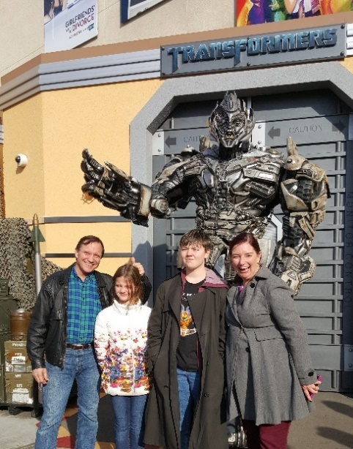
Dust Bunny
I watched a LOT of movies in the last six months. Today I want to recommend three unhinged films that made me happy to go to the movies. These movies show the kind of free spirit that only comes when the artists decide to abandon convention and follow their pure insane vision.
Dust Bunny follows a little girl who witnesses an assassin in her neighborhood, and decides to hire him to kill the monster under her bed. It gets better. The assassin is played by Mads Mikkelsen. The assassin’s handler is played by Sigourney Weaver. The art direction and camerawork are some of the most creative I have seen. It sucks you into what should not be this scary or engaging a story. Is it a dark fairy tale? Is it horror? Is it funny? Yes, yes, and yes. This is the major film directorial debut of Writer/Director Bryan Fuller. Fuller has been writing and producing science fiction and
horror shows like Star Trek and Hannibal. I am so glad someone decided to give him the money to let his freak flag fly on this film. A great time at the movies.

Good Luck, Have Fun, Don’t Die
This wild ride is brought to us by Director Gore Verbinski, the man who brought us the Pirates of the Caribbean movies. Except this time he takes on time travel and street violence to tell a remarkably relevant cautionary tale about AI taking over the world. The movie rests squarely on the competent shoulders of Sam Rockwell. The set up of a man staggering into an L.A. diner swearing he is from the future is just the beginning. Everything spins out of control immediately. Watching this film was like running win-sprints. Every time you think you can get a break in the action, something else unravels and spins you around again. It borrows freely from time travel classics like The Edge of Tomorrow and over-the-top dystopias like Terry Gilliam’s Brazil. A very satisfying rollercoaster ride.

The Bride!
A lot has been said about this marvelous film. I will limit my comments to why I think it is excellent movie making. Yes, it is Bonnie and Clyde played by Frankenstein’s monster and his Bride. Director Maggie Gyllenhaal made no secret of it, using sequences from the famous criminals’ lives and replicas of their cars. The genius of the film was hiring the right actors and letting them completely occupy these over-the-top characters. Christian Bale has a reputation for throwing himself into roles. Jessie Buckley has taken her Shakespearean training and run full tilt into the freedom and rebellion of her second-chance and nothing-to-lose scenario. Even Annette Bening gets to run with her mad scientist daring. The film hits a solid feminist chord, with the Bride starting a Me Too movement in the 1930s. The supporting cast also clearly had fun in this playground. An unexpectedly joyous film.

Have a Drink

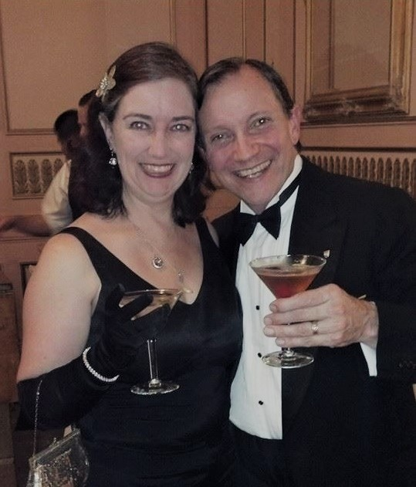
I’ve Been Busy

My choices of films to review in this issue are all wild rides. So was my fall and winter. On top of rewriting The Dove and the Crow twice in that time, and finishing Sins of the Father, I also hosted four dinner parties, three funerals, and squeezed in a getaway to Cancun.
It started in September when my wife Denisen’s mother Eileen passed. She was living with Denisen’s sister Elisabeth in Texas, along with their dad Jim. Elisabeth held a funeral for their mom in Texas so that Jim, who is quite elderly, could attend. Denisen then held a celebration of life out here in the Bay Area for all of our relations out here. Big catered winery event with music from our friends Margaret Davis and Kristoff Klover.

November of course has Thanksgiving. I hosted ten Bay Area relatives for a traditional turkey meal. I was feeling particularly host-like so I made the whole shebang. It was lovely. Our youngest Max had an excellent bonding time with Denisen’s elderly aunt which made the whole affair even more special.

In early December our friend Richard made one of his semi-annual visits to the Bay Area from Portugal. I usually host a dinner for him and our mutual friends, and this time as not an exception. Roast beef with all the trimmings. So, Dinner Party Number 2.

For Christmas, our son and son-in-law could not make it out from Chicago,. Our youngest Max invited their friends, six of them. We had pork loins, complemented with some lively discussion of applied Marxism. Max and their friends are union organizers. Denisen refers to them as the Commie Bookclub. And so, Dinner Party Number Three.

For New Years, Denisen and I were tired of winter rains and we decided, spur of the moment, to go find someplace dry and warm. We drew ever widening circles on the map and finally found someplace dry 3000 miles away in Cancun, Yucatan, Mexico.

Our son and his husband finally made it out for the holidays in early January. So we had Second Christmas, which Max also joined. And so Dinner Party Number Four.

Then, just as things were settling down to routine, Denisen’s father Jim passed. We did not need an event in Texas, so Denisen and I threw the full funeral here in San Francisco. Lodgings for out-of-towners, site, catering, bagpiper, logistics, ashes scattering at sea, the whole enchilada.

After all these events, Denisen and I were reminded that we met planning events at science fiction conventions. We are good enough doing this that we actually enjoy it. She observed that throwing a funeral is very much like throwing a wedding, except instead of having a year to plan it, you have a month.

In between all of this, we of course continued our full time day jobs. And I finished the first draft of the sequel, while editing the first book from feedback.

It seems the only thing I did not do in this six months was write a newsletter. So here you go.

That’s it for this edition. I hope you enjoyed it. Please invite your friends to sign up. I am actively generating content as I never have before. This newsletter is the best place, and in some cases the only place, to hear about it all ahead of publication.

Until next issue, be well!

