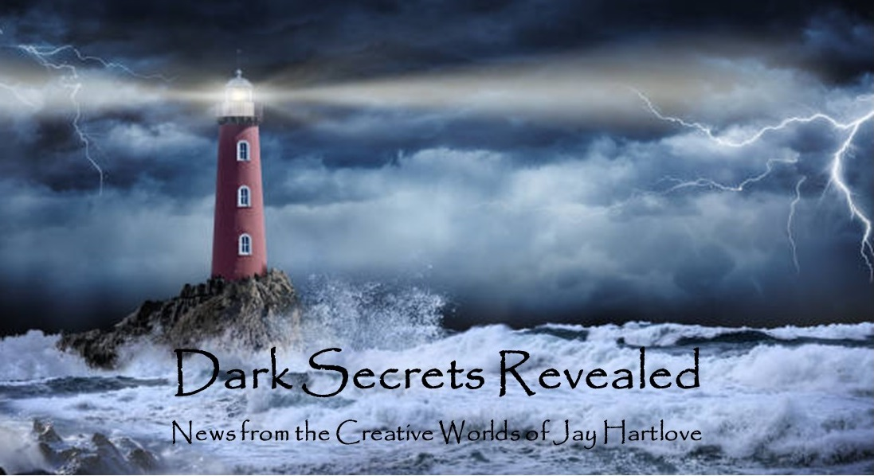
Issue 33 September 2026
In this issue I will talk about the decisions I made in developing the parallel world of Hern. Just how different did the world need to be, or how similar, in order to tell this story? As is usually the case in writing, writers need to decide both what to include and what to leave out.
I also talk about using trauma to inform writing. I spoke on a panel discussing this at WorldCon. I recently saw three concerts where the artists drew from personal baggage to write hit songs.
I got feedback from my beta readers at the Southbay Writers Club on Sins of the Father, the sequel to The Dove and the Crow. Not surprisingly, nearly all of them said the beginning couple of chapters need tightening. Every book I have written started life with a weak opening. Even the ones that have a whiz bang action sequence, like Sins of the Father. In my seminar How to Finish a Novel, I talk about the need to choose the right place to start telling a story. This is a hard-learned lesson. And here we go again. The better news is, they all loved the story I am telling. So onward with the editing!
I put all the back issues of this newsletter up in an archive on my website www.jaywrites.com. Check them out if you joined late and missed some editions.
I would very much like your feedback on this newsletter. Please feel free to write me at jay.hartlove@gmail.com and let me know your thoughts. This newsletter is for you. I could set it up as a sales tool, with lots of buy links, but that’s not why I write it. I do this to share my work and insights with you.
Also, please let me know what you thought of Goddess Revealed. Did you find it interesting? Did it make you want to go back and read the trilogy? Do you think it is a good incentive to sign up for this newsletter?
Here are the usual newsletter columns:
- What’s Cooking: Previews/discussion of what I am actively working on. Also links to interviews, appearances, and other current writing news.
- Mister Wizard: Advice and analysis to help my fellow writers.
- The Aisle Seat: Recommendations. I am a huge movie fan and watch several every month.
- Have a Drink: Wherein I will share personal stories.

What’s Cooking

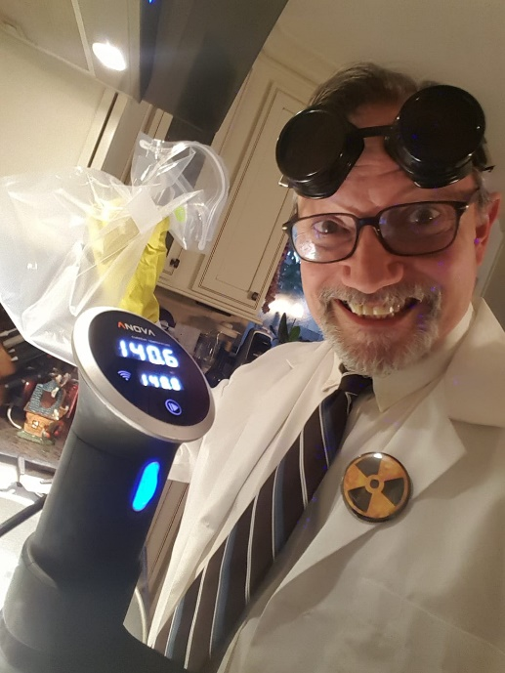
Parallel Worlds
The world of the Dove and Crow books is an alternate, parallel to Earth called Hern. I had to make a lot of decisions about how close Hern is to Earth, and how different it would need to be since it has magic. Not to give anything away, but the people who cause Willa to be transported very carefully chose a world as close as possible to Hern, with the important difference that the target world (Earth) cannot have magic. From the cover blurb and marketing ideas I have shared here, you have probably figured out that Hern is in trouble because it depends on magic and the magic is waning. In Chapter One we learn that a wizard on Hern tries to contact a parallel world, but one without magic, in order to learn how a planet can survive magiclessly.
Hern gets its magic from its gods. The gods each reign over some aspect of the world. For example, there are gods of the sky, of the sun, and of death. They are so powerful their magical influence radiates over the planet. People can train to capture this loose energy and perform spells. Therefore their religion is very important and their gods are literal entities on the planet.
The gods are mercurial, temperamental, argumentative, and dangerously powerful. They are modeled roughly on the gods of ancient Greece. Being a folklorist, Willa figures out their pantheon quickly. As a result of their infighting and various acts of jealousy, the gods have trashed the planet many times over the millennia. So much so, that human civilization has had to start over after cataclysms. Gene pools have been decimated and catastrophes have forced mass migrations. This leaves much geography, many ecosystems, and racial distributions different than Earth. As a result, the technology level of Hern is roughly that of the early 1800s on Earth. In their adventures, our heroines uncover evidence that their civilization once surpassed what we have on Earth now, but was utterly wiped out and had to start over.
Hidden among the obvious differences I have also placed quite a few similarities. Our heroines must deal with misogyny, antisemitism, homophobia, and xenophobic leaders, to name a few. But these obstacles are not what the story is about. So they find ways to work around them, to deal with them, as they move through the story. This is much the same as people on Earth do every day.
Because Willa did not grow up on Hern, she is not immune to common diseases. At one point she becomes seriously ill, only to find out it is their common cold. She spends weeks sick until she grows that immunity. She also needs to be careful with food, since her body chemistry is not exactly the same, and she has reactions to some foods. Again, she and Naomi learn to adapt.
This is not the first time I needed to make such decisions about worlds similar to Earth. Eria, the world of Mermaid Steel, is an even closer parallel to Earth. Other than the supernatural nature of the mysterious goddess Rorra, there is no magic. They obviously have a different history and gene pool, with mermaids and legends of cataclysms. But the reader could walk down a street in Saint Rochelle and fit right in. I did want to make that world very different from ours because I wanted the moral choices to be relevant. The story is about racism and cultural erasure. I wanted the message to stick. Amusingly, one reviewer said, “There is nothing subtle about this book.” I guess that means he read it. My choices I designing that world were mostly the environment, time period and its incumbent level of technology. I placed it essentially on the Goa west coast of India at about 1750. Humid, tropical weather, low sloping coastline, and muzzle-loading rifles are new.
And yes, I did notice that I placed both of these fantasies in worlds similar to Earth with both set in pre- and early-Victorian times. No, they are not in the same world. Although I did tip my hat to that possibility in the storytelling competition in the pub in The Dove and the Crow. One of the bards tells the story of Mermaid Steel. Cheeky of me, I know.
The Goddess Rising Trilogy and The Insane God are set in our real world in modern times. Those are alternate history thrillers. The events of those stories fit in between the headlines of our real world. I went to great deal of trouble to do this in the trilogy. They are set specifically in 2001, 2004, and 2009, with actual news events fitting around my stories. The Insane God is a bit less tied to a specific year, but it is clearly in the early 21st Century due to scientific knowledge and the current political landscape. I say a lot about the radicalization of ordinary people, which needs to be set here and now.
So authors, look at the total reach and effect your stories should have, and make your world building decisions accordingly.

Mister Wizard

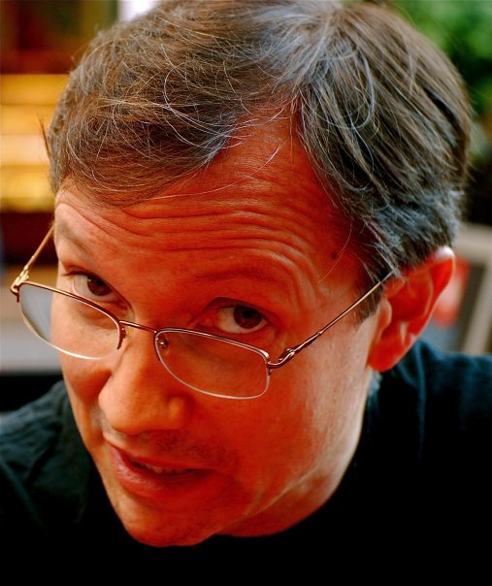
LA Con V
I spoke on four panel discussions at LA Con V, the 84th World Science Fiction Convention. The convention did not schedule me for a reading, but they did set up a book signing for me. My publisher Water Dragon Publishing sold my books from a dealer’s table. And I wore various flamboyant costumes throughout the five days of the con. My new publisher asked me to ramp up my visibility this year before the book release. I was also on six panels at Baycon, which is a major regional convention. But this is WorldCon. I have also applied to be on panels at the World Fantasy Convention in Oakland, California in October. My WorldCon panels were all very good.
How to Change Your Writing Process - When Panters have to Outline
Margaret Dunlap (mod), Benjamin Liar, Max Gladstone, and W. Jade Young. This was a lively discussion. It seems the term Pantsers is confusing (or hard to spell) so it is being replaced with Discovery writers. Even the Discovery writers admitted to keeping track of their stories with some purposeful structure. None of us were hardcore one type or the other. I told the story of my journey from strict outline with the thriller trilogy, to my first attempt at pantsing/discovering with Mermaid Steel. Since seeing that I can do either, I’ve seen the value of leaving yourself room to be flexible and to let in new ideas as you write. I still grow my ideas by iterative passes from a few pages up to a working synopsis of at least twenty pages before I start writing the prose. But allow myself more freedom to incorporate new ideas as I go than I did earlier on. Everyone seemed to appreciate that growth in a writing career. No one had a magic formula and we settled that keeping track of your story elements and arcs was more important than how you got there.
Fracturing Fairy Tales
Caitlin Rozakis (mod), Arendse Lund, Sharon Sheffield, and Sophia Babai. This was very interesting. Arendse is from Denmark and brought an understanding of the folklore behind European fairy tales. Sophia is from Iran and knew the origin of most of what we now call fairy tales. She made the distinction that European fairy tales used to be folklore until folks removed God and demoted them to children’s stories to avoid deletion by the Catholic church. Elsewhere in the world, there is no real fairy tale distinction, they are all still considered folklore, which is revered as an integral part of their culture. I told how I wrote The Mirror’s Revenge as the sequel to Snow White because the original story (which was cobbled together from historical facts) made no narrative sense. My sequel explains what was really going on. We discussed the many, wildly divergent versions of Cinderella. We touched on how fairy tales can be twisted into horror. It really was a great panel.
Swords and Slow Burns: Closed Door Romantasy
Heather Rose Jones (mod), RL (Rebecca) Lynn, Rachanee Lumayno, and Kalyn Josephson. Yes, this was a panel about writing sex, and I was the token male. We discussed why a writer should include explicit sex scenes and why not. We all agreed that romance and yearning were more interesting and more illustrative of characters’ personalities than graphic depictions. I think I was the only one who had written lights-on graphic scenes. I included them in Mermaid Steel because I needed to have the incompatible anatomies of my human and mermaid lovers be yet another obstacle for them to overcome, along with culture, food, religion, music, etc. The overall conclusion was, if you are going to go graphic, then you should have good reason, and it should be important to the story.
Trauma vs. Entertainment
Brandon case (mod), RL (Rebecca) Lynn, Robert Mitchell Evans. One this panel, Rebecca was the token female. Which was interesting because so much of trauma that it shown in popular media is about bad things happening to women. We talked about both how trauma is shown in media and how our own trauma influences our writing. I commented that at the end of my thriller novels I suspect all the characters will need therapy to recover from what I put them through. Rebecca shared her perspective as a woman seeing trauma inflicted on women in fiction. Robert made several cogent points about only inflicting traumatic events on characters when it makes sense for the story and the reader. It was a remarkably elevated conversation for the afternoon of the last day of the convention.
I also attended panels on Cozy Fantasy, using social media reels to build a brand, and separating art from the artist. The social reels panel confirmed what I suspected, that reels can grow a following but it is a full time job. To build and keep an audience, one must post every day or every other day, and post almost entirely community building material, like book reviews, and not promote your own work directly. I recommend things that I find worthwhile right here, for you.
The separating art panel explored the ethics of appreciating art even if you find out the artist is reprehensible. The panel tried to land on some guidelines, but really only proved that this is a personal, subjective decision that everyone makes for themselves.
The Cozy Fantasy panel was very helpful. I have been struggling with defining cozy since I’m pretty sure the Dove and Crow books fit this label. I attended this panel early in the convention, which set a tone that wrapped up with the trauma panel on the last day. The panel talked about how cozy stories are usually set in a limited environment, like a small town. They made a distinction between the stakes of what is at risk and the danger that the characters face. Cozy stories often have low stakes even if the danger is high. The most important conclusion was that in cozy stories the characters have space to work out their reactions to the events of the story. Things work out. The events of the story do not traumatize them or add to their need for therapy.

The Aisle Seat
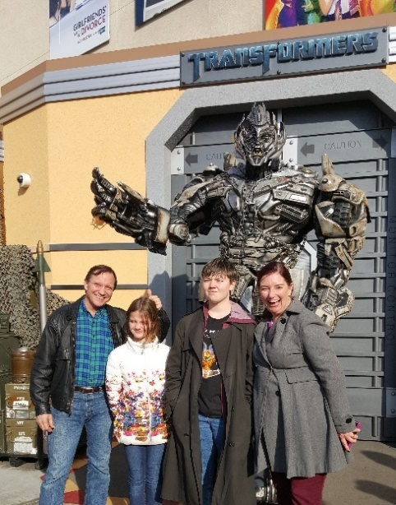

Backrooms
This month I review three horror films, two that worked better than I expected, and one that did not work for me at all, even though it is very popular. All three show how creepy can be built into dangerous. These did not come out in July. I saw them during the first half of this year. They are available on streaming if you want to check them out.
Backrooms disappointed me. Maybe it was the clever set up that had so much potential that did not play out. Studio A24 gave Director Kane Parson the chance to expand his Youtube short films into a feature film. The original shorts were hugely popular because the set-up is indeed quite chilling. He takes a familiar setting and makes it too big, too empty, too mysterious, which leads to it being threatening. But the set-up can’t sustain a narrative. The first act
successfully turns mystery into creepiness. The second act is repetitive and frustrating when it should be building fear. And the third act is a letdown with a lame, incomplete excuse for an ending. Kane says he has more story to tell. Maybe he didn’t want to give away too much in this film. He lost my interest.
Apex
An experienced ultra-sports enthusiast tries her hand at a challenging set of whitewater rapids, but finds herself pursued by a local guide with murderous intent. He knows the canyon very well since this is his home turf. But she is more capable of surviving than he realizes. He takes her as a challenge. This is the slasher model played out against competency porn. She does everything right, unlike so many slasher film victims. But he keeps coming like Jason or a Terminator. As a result, the film builds suspense and fear rather than creepiness and jump scares. Suspense is frankly harder to create. The first act shows us the helpful guide is a stalker. The second act shows he is actually a killer. And the third act shows the extent and history of his murderous career. Slowly unveiling how bad the antagonist is while progressively showing us how competent the protagonist is builds tension better than I expected from such a simple story.
The Boy
This film also worked better than I expected. You know from the first few minutes that this will be a creepy ghost story, which sets a bar against all the other creepy ghost stories you’ve seen. Creepy horror is a unique genre in that audiences expect a slow start. The story needs to pique intrigue and draw the audience in, but these stories don’t start with a flashy hook. A young woman arrives at an old mansion to start work as a nanny only to find her ward is a doll that his elderly parents treat like a living child. She assumes they are eccentric, which is proved out when she learns they had a child who died and the doll is their proxy. Weird but sad and sympathetic. Of course this escalates and soon the doll is actively terrorizing her. Things really get out of hand when the parents permanently take themselves out of the picture. The film builds tension into terror very well, and gives what I found to be a very satisfying ending.

Have a Drink

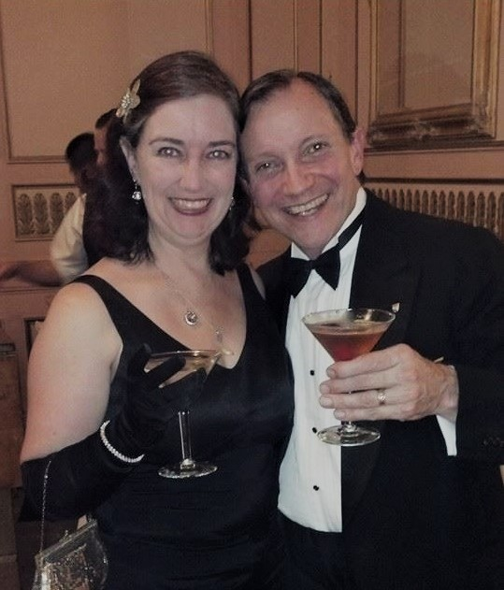
Writing and Singing About Trauma

This summer we have seen a lot of live music. We went Biscuits and Blues, our favorite jazz club in San Francisco, to see Lavay Smith, a singer we have followed for many years. We went to the Art Deco Preservation Ball and listened to the big band sounds of Alex Mendham and His Orchestra. We also went to three concerts where the singers showed a personal side of their artistic journey.

We saw Evanescence at the Shoreline Theater in Mountain View. I first saw them at San Jose State twenty years ago. The stadium there is a concrete box of a basketball venue. The sound was trapped and quite aggressive. I came away inspired to write The Mirror’s Revenge after seeing Amy Lee pour her heart into Bring Me to Life. The song showed me Snow White’s inner journey. It

turns out, Ms. Lee was singing about her therapist bringing her back from self-harm. When we saw them this summer, twenty years later, she was a polished performer who could deliver songs about her previous trauma for the audience to enjoy without getting too caught up in the lyrics. Even with the polish, it was clear that may of her songs came from a place of pain and recovery. Her heartfelt content appeals to young and old alike, and we saw a wide mix of ages at the show. Most prominent, though, were the vampire goths who filled in the lawn once the sun went down.

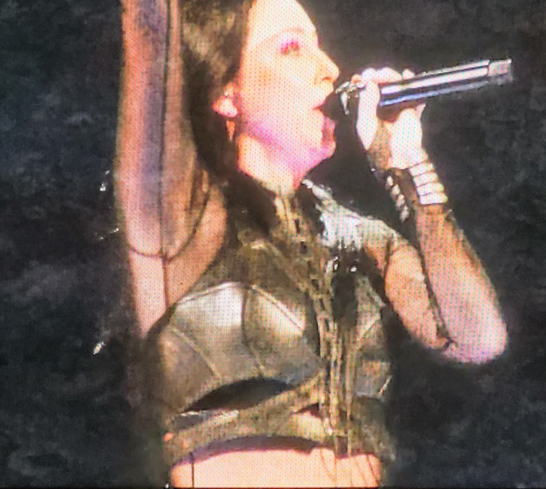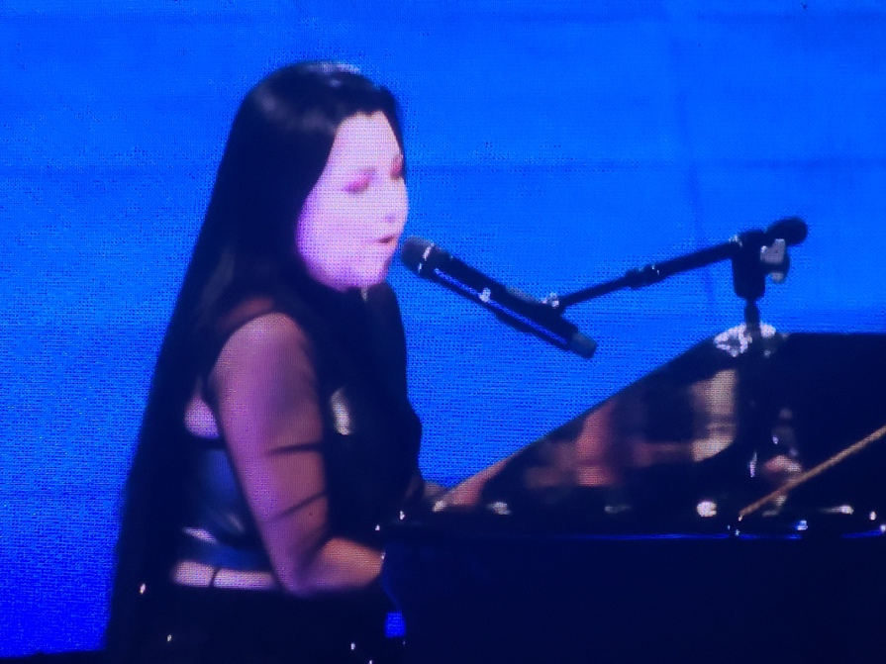

We also saw Sarah MacLachlin at the Concord Pavillion. Her music has a lot less dark imagery than Evanescence, but it still comes from suffering and growth. I would venture to say that a majority of her songs are about failed relationships, either the pain of lovers doing her wrong, or the regret of her having hurt friends. She was remarkably self-deprecating during her talks to the audience between numbers, telling funny stories that were actually admissions of mistakes that inspired the music. Truth comes through in lyrics like, “I messed up, better I should know. Don’t come round here and tell me I told you so.” While it made her more sympathetic and identifiable, it also showed that big emotions are a deep source for creativity. Listening to her sing about longing and loss reminded me of the emotions I am tapping in the Dove and Crow books, which are of course about love healing old wounds.
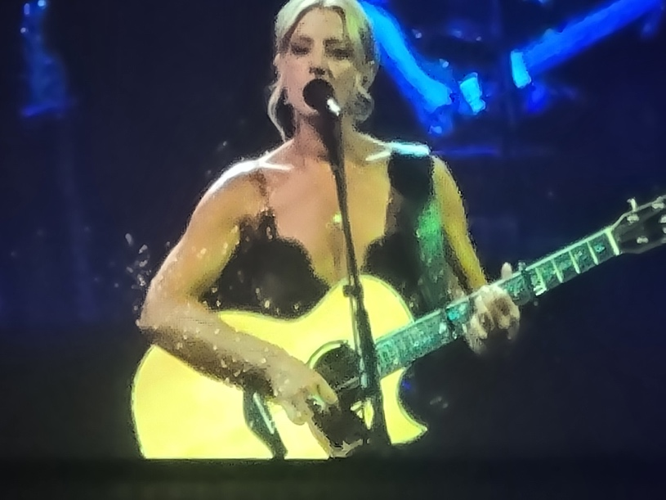
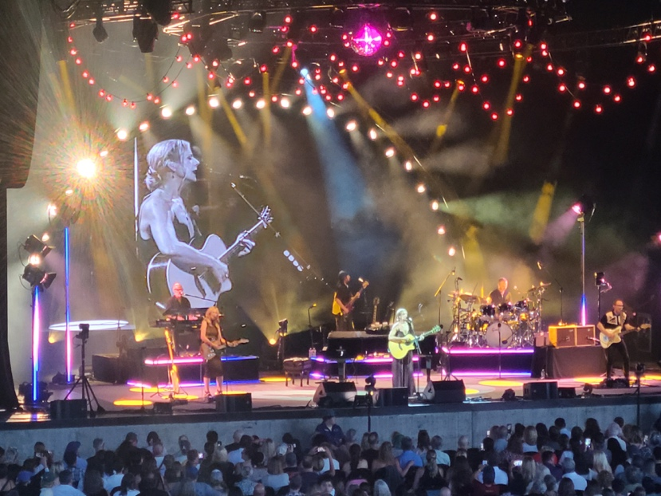

Most recently we saw Kelly Clarkson at Caesar’s Palace in Las Vegas. We thought we were going to see a pop concert but this was also a very personal show. On the surface, her hit songs fit the somebody-done-somebody-wrong mold, but listening to her give context was eye-opening. Childhood abandonment and its incumbent self-doubt, followed by multiple failed romantic relationships has left her with an ocean of inspiration for songs that resonate with all of us. Lyrics like, “I never stray too far from the sidewalk…Because of you I am afraid,” hit harder when you realize she didn’t just make up catchy words. Didn’t see that coming.

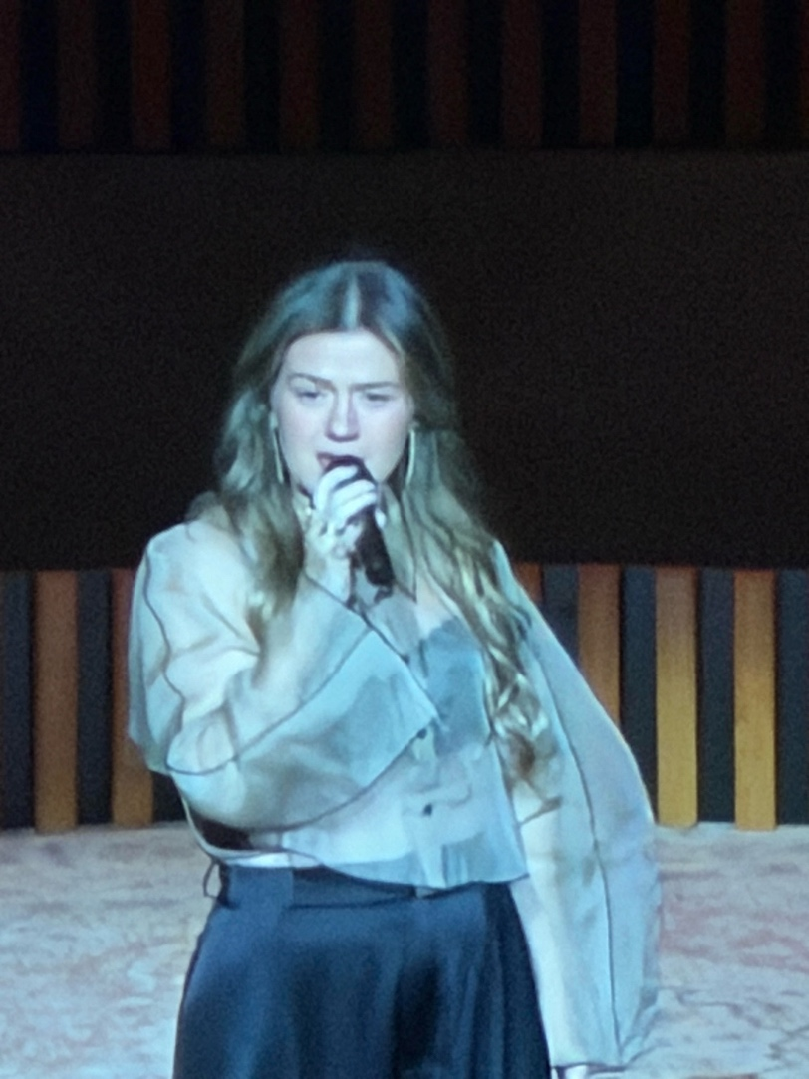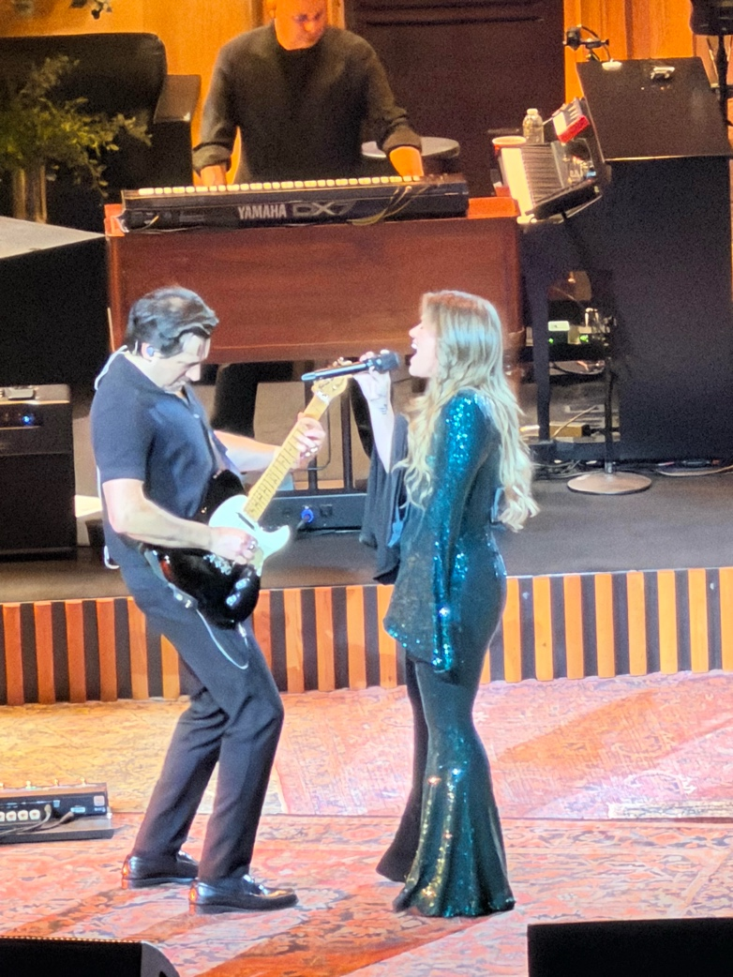

The sages would have us believe that to err is human and to forgive is divine. Are these songs popular because we all screw up? Or are the songs about trauma reflective of how many of us were raised, were betrayed, or otherwise grew up with heartache? I have often joked that writing my books has been a course of therapy. In Goddess Daughter I wrote about betrayal from personal experience. In The Insane God I wrote about transphobia from the lived experience of raising my kids. In the Dove and Crow books, Willa has a string of failed relationships and self-esteem issues because of an abusive father. Her father came back from the Vietnam War with PTSD which he took out on his family. My father came back from WWII with the same problem. Of course PTSD wasn’t recognized as a disease until after the Vietnam War, so my dad led his life angry at the world with no medical help whatsoever. Being backhanded across the mouth at random times for no apparent reason rewires a kid.

America has been at war with somebody continuously (except for one year during Jimmy Carter’s term) for its entire history, ever since Thomas Jefferson sent war ships to defeat pirates in North Africa. Is it possible that every generation has had a round of fathers return with battle scars that were passed on through traumatizing their children? Way too many people identify with abusive parents, fathers in particular, for it to be random.

Whether we can pin an epidemic of bad parenting on war, or whether parents are of necessity rank amateurs when they first have children, we have a huge proportion of the populace ready to identify with art that speaks to trauma. My hope is that while I am working out my own issues through writing, my books will also resonate with, and maybe even help, folks who also wear the scars.

That’s it for this edition. I hope you enjoyed it. Please invite your friends to sign up. I am actively generating content as I never have before. This newsletter is the best place, and in some cases the only place, to hear about it all ahead of publication.

Until next issue, be well!

