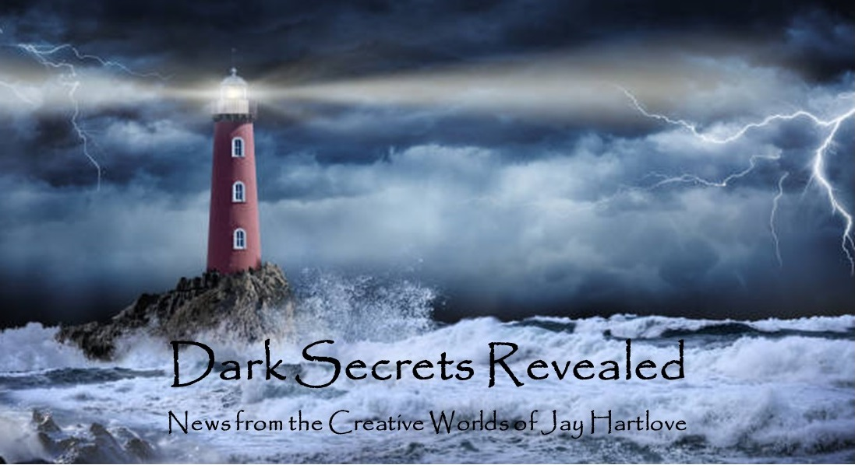
Issue 29 September 2025
August was delightfully busy, which is why you’re getting a September newsletter. Worldcon in Seattle was a whirlwind of good things. I have made great progress on The Sins of the Father. I have started (revived, actually) a major costuming project. And I’ve started work on the music for The Two Flowers. I talk about these below.
I put all the back issues of this newsletter up in an archive on my website www.jaywrites.com. Check them out if you joined late and missed some editions.
I would very much like your feedback on this newsletter. Please feel free to write me at jay.hartlove@gmail.com and let me know your thoughts. This newsletter is for you. I could set it up as a sales tool, with lots of buy links, but that’s not why I write it. I do this to share my work and insights with you.
Also, please let me know what you thought of Goddess Revealed. Did you find it interesting? Did it make you want to go back and read the trilogy? Do you think it is a good incentive to sign up for this newsletter?
Here are the usual newsletter columns:
- What’s Cooking: Previews/discussion of what I am actively working on. Also links to interviews, appearances, and other current writing news.
- Mister Wizard: Advice and analysis to help my fellow writers.
- The Aisle Seat: Recommendations. I am a huge movie fan and watch several every month.
- Have a Drink: Wherein I will share personal stories.

What’s Cooking

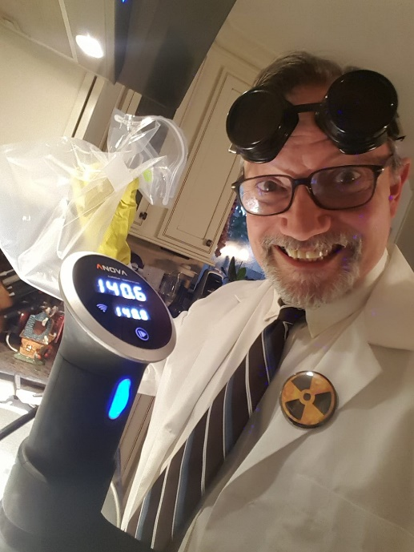
Worldcon Seattle 2025
The World Science Fiction Convention was held in Seattle, Washington from August 13 through 18. Denisen came too. She often skips conventions due to running her own business. I’m glad she could make this show. We had a great time.
I did not sign up to be on any panels in advance. I agreed to spend some time manning the table for the World Fantasy Convention which will be in Oakland, California next October 2026. I am running the mass autograph session, which is a staple of WFC. But otherwise my plan for Worldcon was to attend my friends’ panels and catch up with folks I rarely see.
I did in fact see lots of my friends, some of whom I had not seen in

decades. I organized a Facebook group chat ahead of the con to help organize meet ups and meals. It worked beautifully. We didn’t spend a single meal alone. Most of these friends are from the costuming community. This community works on the artificial neighborhood model. We live all across the country, but stay in touch as if we were neighbors due to our binding thread of building costumes. Such a neighborhood has all the same features of a geographic one, including over-the-back-fence gossip, trading recipes, lending a hand on projects, and mentoring each others’ kids. Denisen and I wore our Lady Olenna and Prince Oberyn costumes from Game of Thrones in the halls. (See Issues 7 and 8 (April & May 2023) for a photo essay on making those outfits.)

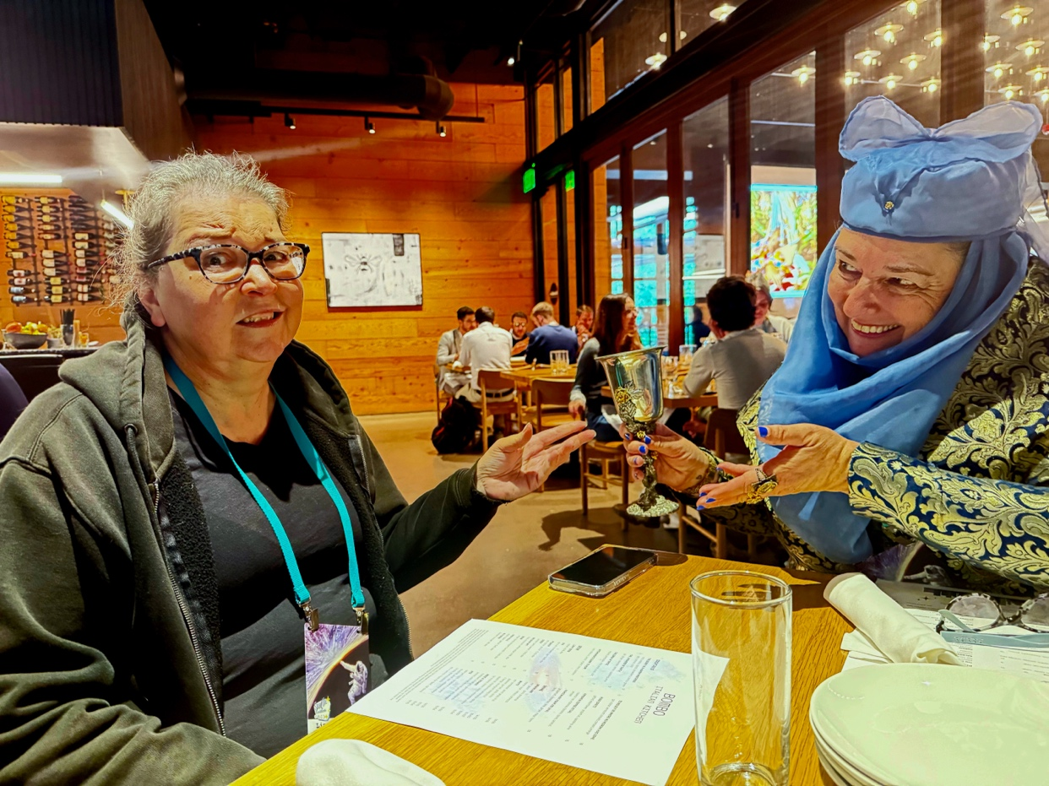
I also caught up with some professional contacts. I had delightful conversations with David Brin, who endorsed The Insane God, and Lee Moyer, who painted the cover for Mermaid Steel.
The convention was over programmed, even for a Worldcon. At any one time, you had to choose which panel or demo to see from a list of 25. Yes, 25 concurrent tracks of programs. I saw indie writers doing readings, which is rare for a show this size. It seems the convention just kept saying yes. The convention hall they had was gigantic: four floors with twenty conference rooms on each floor. The con filled the building. I spent most of my time either meeting and eating with friends, or perusing the huge dealers’ room and art show. I think I attended four of the 300 panels that were offered.
Because I can never leave well enough alone, I also volunteered to help with the Masquerade. The show had 47 entries, which is a good size given that conventions were shut down by the pandemic only two years ago. There was a nice mix of novice beginners and experienced masters. It’s always good to bring new people into the art, especially young people who will keep costuming alive into the future.
The Master of Ceremonies was efficient, quick-witted, and funny. He put on a good show. The masquerade itself was poorly run. Their tech crew did not get the hall until midday, so the rehearsal run-through did not have entries’ music ready. The ramps and stairs onto and off of the stage never got adjusted to meet the needs of the larger contestants. The green room was too small and was missing a lead. The den mothers were left to figure out the running order and how to shepherd their entries to official photography and workmanship judging. I and the other stage crew who were not busy with the front-of-house pitched in and drew up lists and coordinated as best we could. There were several times when chaos reigned. The one catcher in front of the stage was given bad instructions and we had a costume dance right off the front of the stage. Fortunately the costume was made of foam and the contestant was not hurt. But the incident added to the overall chaotic experience of the costumers. I think things would have run much more smoothly if the convention had assigned one more staff person as the green room lead. Den mothers have their hands full taking care of their charges. And stage crew have no authority to organize matters.
All of my experienced consuming friends gave their breakdowns of what could have been done better. I know the couple who are running the masquerade for Worldcon next year in Los Angeles. They ran the masquerade at Worldcon seven years ago in San Jose. BY all accounts, they ran a good show. (I did not see that masquerade because I was busy moving The Mirror’s Revenge from San Jose to Vallejo for the opening night in our theater venue.) All my friends made sure they got the advice.
Seeing my sixty-something year old friends producing top notch work get me thinking about projects I have put aside for too long. I discuss the results of that remuneration in an article below.
Seattle was lovely. The weather was beautiful. Denisen and I spent a whole day being tourists in the Pike Street Market which was only a few blocks from our hotel and the convention center. On another walk we made it to Voodoo Donuts, so we had snacks in our room for the weekend. All in all, it was a very worthwhile and memorable good time.

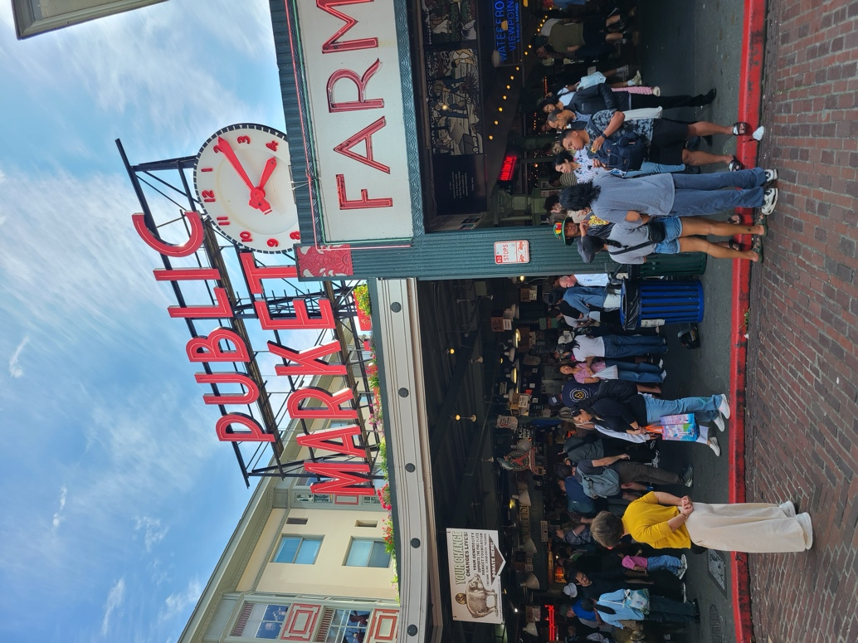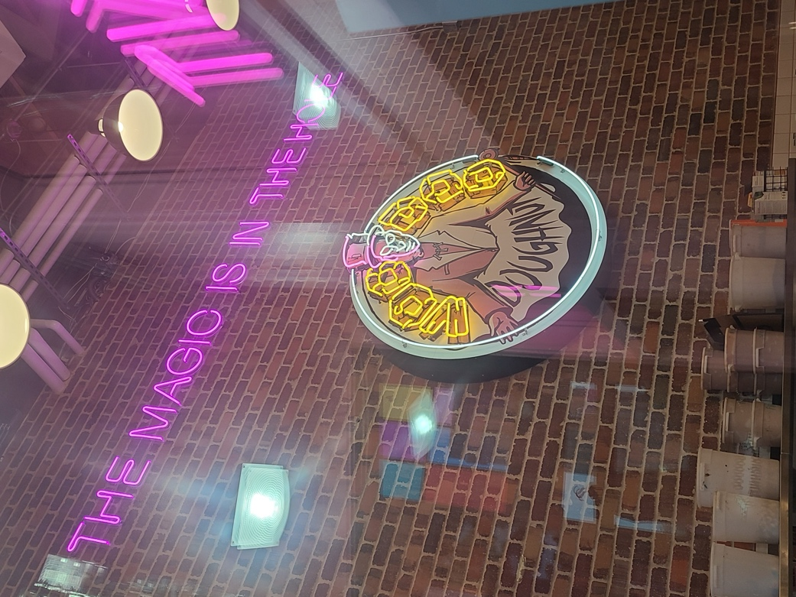

Mister Wizard


Genres vs. Markets vs. Audiences
By now you are probably sick of hearing me talk about the usefulness and hinderance of labelling books into genres. Please hear me out. I think I have finally figured out something actionable.
Of course genre labels are applied to help readers find the kinds of books they are already looking for. No book cover or back cover blurb is going to pull a nonfiction reader into your epic fantasy trilogy.
For years I have been preaching that if you direct your writing to chase a popular trend then by the time your book is published, it will be yesterday’s fad. Moreso, if you are not writing material that truly excites you, your language is likely to reflect that and the audience will see your lack of fire.
Let’s say you’ve written from the heart and produced exactly the book you always had in mind. How can you use genre labels to find the people who are looking for your kind of book? In other words, ask not what genre it fits into, but rather who are the readers who want this kind of book? It may be obvious from the conventions and tropes you have used that your book is a particular genre. But that doesn’t tell you who to aim the book marketing towards.
Maybe your book is a Spy Thriller. So you pin that label on it and hope everyone who loves Spy Thrillers will see your book and buy it. No, the real world does not work that way. Who is your protagonist, and how will that influence potential readers? A two-fisted ex-soldier male protagonist will appeal to a different audience than an erudite highly trained female spy. What about setting? Stories that take place in the Syrian desert will appeal to a different audience that those set in Steampunk Victorian London. You can see why “Spy Thriller” isn’t really drilling down to who your likely readers are.
The cover, the title, the cover blurb, even your identity as the writer will help or hinder the book from finding its readership. 80% of fiction readers are women. Nearly 100% of Romance readers are women. It is no coincidence that 90% of Romance writers are women. A larger proportion of Erotica is written by men. Women readers are suspicious of male Romance writers because there is a likelihood the story will be told through a male gaze. I encountered this with Mermaid Steel. I have had women look askance at the book when they see it was written by a man. When I talk about it, I always make the point that I wrote it from both the male and the female points of view because I was as interested in telling the mermaid side as the human side. The fact that my lovers are different species overrides the suspicion of a gender bias.
When I tell readers the story is about racism and cultural erasure, I have to use the same 50/50 lens to answer why I, a white male, should be telling a story about racism.
I wrote about transgender people and mentally ill people in The Insane God. I researched my subject matter down to the bare metal and used sensitivity readers to fix my missteps. Trans readers have told me how happy they are with how I got it right. Cis readers have told me they learned important things about the trans community from the book.
It seems I have developed a reputation for writing outside my own white, straight, cis male mold.
But now I have painted myself into a corner. The Dove and the Crow is first and foremost an adventure story. Outsider Willa convinces gifted Naomi to undertake Sinbad-like quests to find cures for the planet’s ills. To shine light on this, I have rewritten the back cover blurb to say:
A desperate wizard accidentally pulls literature professor Willa Friedlund into a parallel world of magic, monsters, and mercurial gods. When she learns Hern is in danger, her storytelling convinces the witch Naomi to join in a grand adventure to save the planet. Willa’s understanding of mythology helps her fit in, but it is her experience with abuse that leads her on a quest to free an enslaved goddess and restore the balance of magic that is essential for her adopted home to survive. As Naomi helps Willa to heal, Willa learns to heal her new world.
Given my previous books, no one is going to doubt my ability to write an adventure story. Given that the protagonists of my successful Urban Fantasy trilogy were strong females, I have some credibility telling stories with female leads. But this one crosses a line. I have my two female protagonists fall in love. And they do so as an integral part of the story being told, not just for window dressing. The vast majority of lesbian romances are written by women. Women readers trust female authors. On top of that, this is a story about rising above relationship abuse which is almost always reserved for stories about women written by women.
This is a Sweet Romance. I spend no sexy time with the lights on. That’s not the kind of story I’m telling. I had assumed I could avoid accusations of male titillation by keeping the sex out. Now I’m not sure that gives me the coverage I once thought.
Even though my writer friends say you should be able to write about anything if you write from the heart, do your homework, and stay respectful of your subject, this doesn’t convince a random reader that they should trust you to tell a story that they will take personally. Given that my book has taken me into the company of almost entirely women who write for an entirely female audience, the book may be doomed to an identity crisis.
I have given the book to a female romance writer friend for her critique. In particular I asked her to read it keeping in mind that the author is a man. I will let you know what she says. In the meantime, I still have not gotten an answer from the publisher who has had the book for six months now. He gave me notes in the first month, which I happily incorporated. I have to wonder if his hesitation is fueled by this same marketability issue.
Should I consider a bit of fraud and use a female pen name? Would that convince anyone? Would the fraud bring further negative reaction? If the pen name is successful, then no one will know they should go read my back list. I’m not convinced the pen name is a good solution.
I think my only path is to push through on the book’s merits. If I can get glowing pre-publication reviews from major trusted sources, then maybe the readers who should read this book will trust it long enough to pick it up. If Publishers Weekly and the New York Times say the book works, then maybe women will try it despite the male writer. Fingers crossed.
Of course I did not think of any of this when I wrote the book. I will continue to write what most inspires me. But this is the last time I let myself wonder blindly into a territory without first considering who will likely read the book. The lesson is, don’t chase markets or trends, follow your passion, but keep in mind who will pick up the book and how it will be perceived.

The Aisle Seat
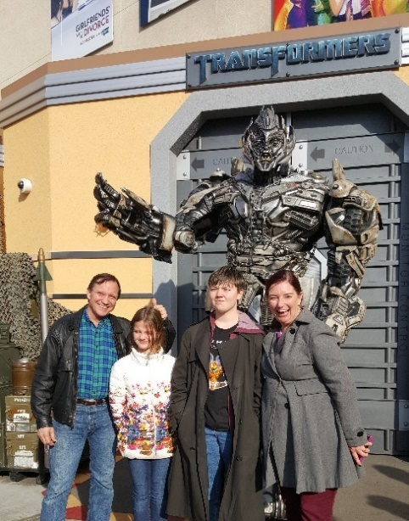
The Return
This month I review three movies that take myths in new directions. I grew up on Bullfinch’s Mythology and I tend to write stories that bring a moral to the adventure. When I researched The Goddess Rising trilogy, I dove into religions and myths from around the world. I am having a lot of fun writing Willa Friedland, the protagonist of the Hern books, who is a mythologist.
The Return tells the very personal story of Odysseus’ return home from the Trojan War. The myth tells how his wife Penelope had resisted the attentions of suitors for the entire twenty years her husband was gone (ten years fighting the war in the Iliad and ten years fighting to get home in the Odyssey) believing he must still be alive and would return to her. What is not usually included, and what this film explores, is why he delayed his return even after his

men were all killed by the gods’ torments and he made it most of the way home. Penelope had heard a rumor that he was on a nearby island, and may have even taken another wife. When he does return and sees that she waited for him, he is ashamed to have waited. The suitors have gotten out of hand and are threatening to seize her and the island of Ithaca. He steps up, and as told in the myth, kills them all with his old bow that no one else can even string. The emotional center that this film brings to the myth is why he stayed away. I will not spoil it for you, but it is positively Shakespearean. Ralph Fiennes slays this role. Juliette Binoche is also wonderful. Highest recommendation.

Death of a Unicorn
A father hopes to bond with his teenage daughter by taking her along to a retreat in the woods hosted by his billionaire boss. En route, they accidentally hit and kill a unicorn. He was nervous about the retreat to begin with, and now he tries to hide the death of what must be a protected creature. You know you’re in for fun with a horror comedy starring Paul Rudd, Jenna Ortega, Will Poulter, Tea Leoni, and Richard Grant. The billionaire boss has been experimenting on the unicorns, hoping to develop a life extending elixir. The unicorns turn out to be far more powerful than expected. Much of the humor and horror comes from finding out just how powerful they are. But are they the monsters? The film is fairly predictable and the CGI breaks down in places. The comedic timing makes up for it. And it has a Hollywood happy ending. Not my highest recommendation, but it was fun. Catch it free on streaming.

The Fall
On the other hand, I can’t say enough positive about The Fall. If you’ve seen Tarsem Singh’s 2000 film The Cell, you know how daring he can be with his visuals. While I loved The Cell, its story fell a little flat for me. The story in The Fall works on every level. An injured stuntman who is contemplating suicide meets a young patient while in rehab and concocts for her a mythic adventure tale. He clearly has his own motives for telling the story (drug seeking being the obvious), but the story has so much potential for a happy ending, the girl and the audience keep listening, hoping it will turn out well. I really don’t want to say much more because of spoilers. Suffice to say, a film about hope and doing the hard work to keep hope alive, told through some of the most beautiful images I have ever seen on film, just swept me away. Myth making at its best.

Have a Drink

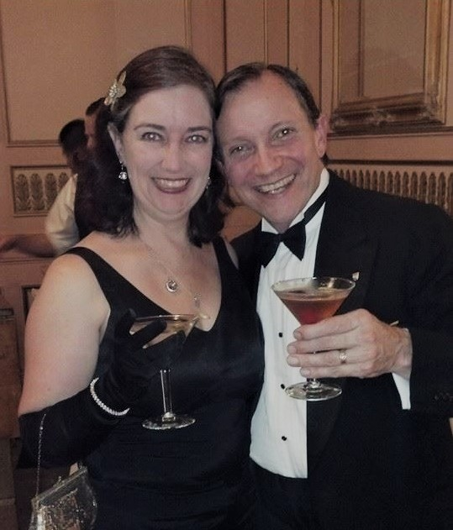
Nuk Nuk the Fishman

Fully forty years ago I designed a costume for H. P. Lovecraft’s Deep Ones. I made prototypes for the functional parts. At the time, the favored cosplay material was Friendly Plastic. We all learned the hard way that Friendly becomes brittle with age. My prototypes all disintegrated and I abandoned the project.
Since then, new, much more durable materials have become available. Yes, I am reviving the build.
The centerpiece of the costume is the eyes. Eyes that move, especially when they move ahead of a head movement, as if looking then turning, create a strong illusion of life. The design

starts with bubble style motorcycling goggles that have been painted to look like eyeballs, with round dark sunglasses lenses as the pupils. These line up and fit into larger round clear domes that are part of the face shell. By having the right amount of space for me to turn my head, the creature’s eyes will rotate before my head then turns the creature’s whole head. The prototype I made years ago worked beautifully. In the intervening years, my eyesight has deteriorated. The eyeball goggles will now also be fitted with prescription lenses so I can see clearly.

The jaw will be on a lever connected to moving gill slits. When the mouth opens, the gills close, and vice versa, creating the water pumping action of fish.

The eyelids and the fin on top of the head are actuated with motors.

The hands and feet are “evolved” from fins. The fingers and toes start well up on the wrist and calf, fanning out to form hands and feet, with a thumb or heel as an extra digit.

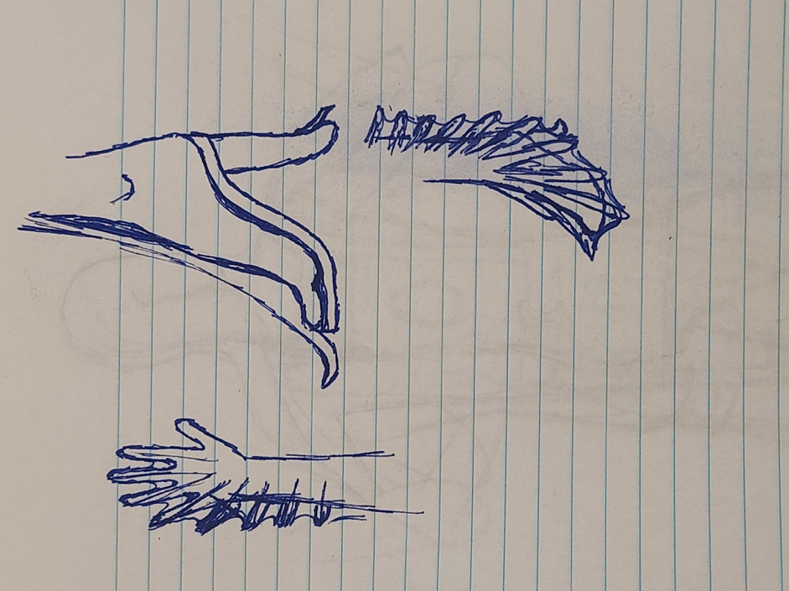

The neck is bent down for the face to look forward. In the water, the creature would lift its head level with its body to swim. When walking on land, the head would be folded down, forming a hump out the back.

Most of the body sections will be made of EVA foam sheets. These are a stiff, closed-cell foam rubber that can be tailored and molded with heat. Lots of costumers use it for armor. I have in mind to tailor it into body shapes. I also have a very thin foam sheeting that I plan on using to make skin. Fish are very smooth, even with scales. Creating a shiny smooth skin will be a fun challenge.

The overall concept is to hide me inside the foreign shapes. If I can get the proportions right, it should not look like there is a person inside the suit.

My target is Worldcon in Los Angeles next August. Wish me luck.

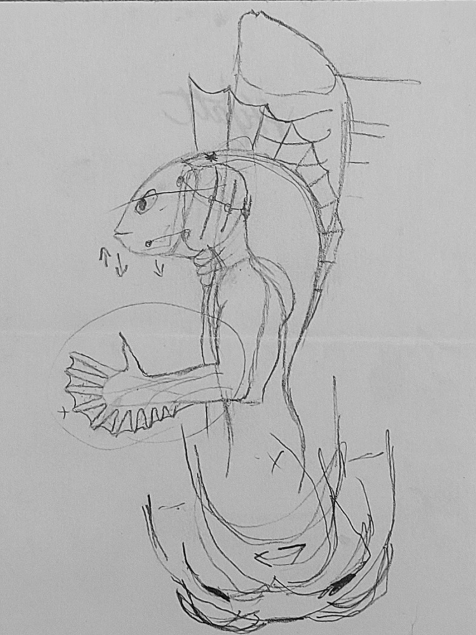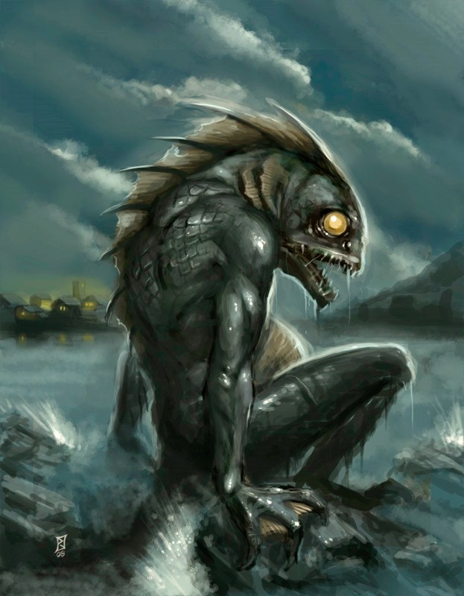

That’s it for this edition. I hope you enjoyed it. Please invite your friends to sign up. I am actively generating content as I never have before. This newsletter is the best place, and in some cases the only place, to hear about it all ahead of publication.

Until next issue, be well!

