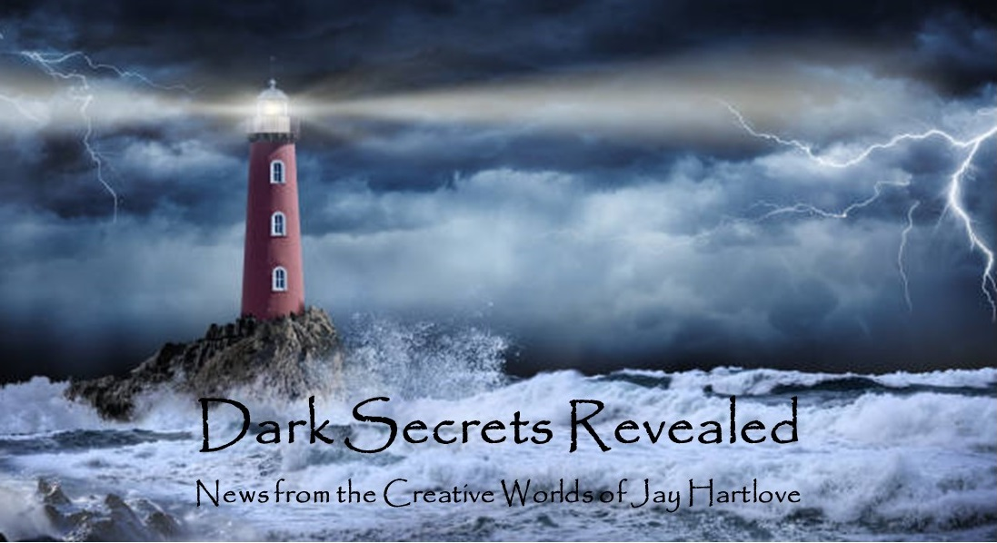
Issue 27 June 2025
I apologize for the slowdown in these newsletters. No, you did not miss a May edition.
I have spent way too much time over the last two months watching politics. Waiting to see what shocking thing happened today has turned us all into lottery gamblers. We breathlessly watch to see if any positive numbers come up, knowing how unlikely that is, only to be disappointed again, until we return to our screens tomorrow with new hope. As of this writing, the only arm of our government that seems to care about decency is the Judiciary, and Congress is about to kneecap them with the Big Beautiful Bill. History will remember this turning point, as much we wish it would go away.
Our twenty-year old has revolution in their eyes. They’ve joined a group who are reading political history, trying to make sense of our times. My wife and I call it the Commie Book Club. In addition to Trotsky, they are also learning how to avoid being cornered by the police during protests. At least they are engaging the process, which is more than most people are doing.
The book pitch fest I attended in March netted me a few contacts. Of the four agents/publishers I pitched to, two so far have rejected The Dove and Crow. I have not heard back from the other two. After two months, I don’t expect to. Out of the blue, my freelance editor told me a publisher she works with had opened up submissions. He likes the book enough to give me some editorial suggestions. I resubmitted it with his changes, and I am awaiting his final decision to buy it. I should have probably led this newsletter with that news. But since I don’t know yet, I didn’t want to get you too excited.
I sent the short story Ashes (which I shared with you a couple of editions back) to four magazines that appear to publish “weird” stories. They all rejected it. I recalled a friend who publishes fanzines liked the pitch I made years ago when the story was just an idea. In addition to his three fanzines, Chris has a pro literary magazine called Literature for Laundrymats. I asked if he wanted to see it, and he said yes. So Ashes may see print after all.

I put all the back issues of this newsletter up in an archive on my website www.jaywrites.com. Check them out if you joined late and missed some editions.
I would very much like your feedback on this newsletter. Please feel free to write me at jay.hartlove@gmail.com and let me know your thoughts. This newsletter is for you. I could set it up as a sales tool, with lots of buy links, but that’s not why I write it. I do this to share my work and insights with you.
Also, please let me know what you thought of Goddess Revealed. Did you find it interesting? Did it make you want to go back and read the trilogy? Do you think it is a good incentive to sign up for this newsletter?
Here are the usual newsletter columns:
- What’s Cooking: Previews/discussion of what I am actively working on. Also links to interviews, appearances, and other current writing news.
- Mister Wizard: Advice and analysis to help my fellow writers.
- The Aisle Seat: Recommendations. I am a huge movie fan and watch several every month.
- Have a Drink: Wherein I will share personal stories.

What’s Cooking


Out in Public
I had a booth at the California Mermaid Convention a couple of weeks ago. This is the third year they have held it at the Hagan Community Pool complex in Rancho Cordoba, California, just outside Sacramento. The event grows each year. The activities start Friday with a parade and welcome party. There is a ball Saturday night after a day at the pool. And then a second day at the pool for people to connect and get their underwater photographs. I only attended Saturday day. There were over 30 vendors and over 200 attendees. It was a perfect spring day, not too hot or cold. As always, there were lots of amazing outfits. My favorites are usually from KT at CreatureFins. This year was no exception. Her Sea Dragon is shown below. I held an hour long panel on Mermaid Steel. A dozen people attended and I sold five books, which is a

respectable book signing day. Yes, Chielle accompanied me. The event is a lovely escape from reality, so entirely welcoming and joyful. I’m really glad I’ve connected with this group.
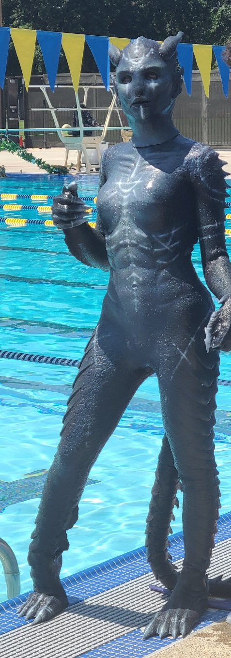
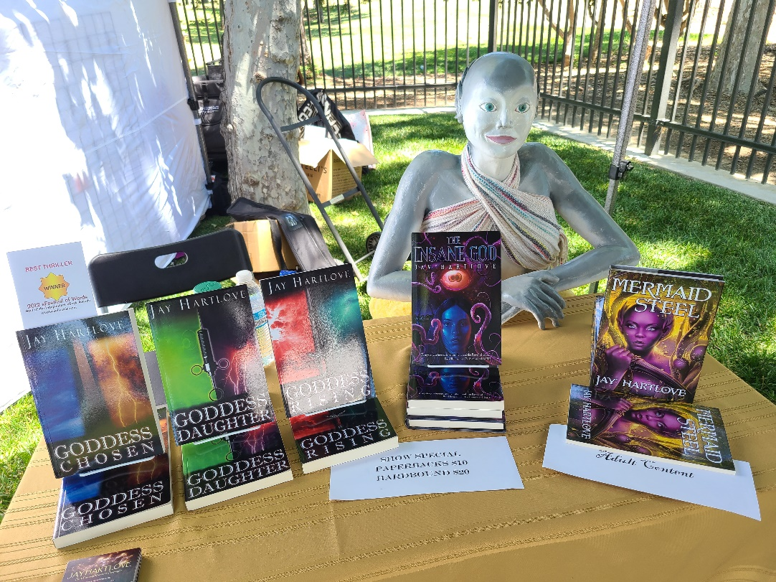
I’ve been going regularly to the Science Fiction in San Francisco “SF in SF” reader series. I’ve heard some luminaries read from their latest works. I’ve also had some engaging conversations with them over dinner afterwards, in particular with Garth Nix, Daryl Gregory, Karen Joy Fowler, and Pat Murphy, and Gail Carringer. The series has been running for over fifteen years. Rina Weisman runs it along with her husband Jacob, who is also the driving force behind Tachyon Publications. Rina is also the Chairperson of the World Fantasy Convention that will be held in Oakland next November. (I will probably be helping her with that enormous enterprise.) For years they ran the reading and discussion sessions in the Book Binding Museum in downtown SF, but last year they moved it to a speakeasy theater in North Beach called The Lost Church. My friend Cliff Winnig usually hosts the interviews. It is great to have a regular event to stay connected to a writing community.
It has also been reaffirming to chat with successfully published authors and find that they share many of the techniques I have developed in isolation. I was thrilled to find, for example, that Gail Carringer (with 40 books and over 2 million copies worldwide) uses the same cover-blurb-as-mission-statement method for holding onto the original spark that got you excited enough to start writing the book.
Last weekend, I was part of the team that put on the 4th Annual Clayton Pride Parade and Festival. We had 54 entries and about 3,000 people attended. We hold this festival in a very conservative town for the obvious reason that places like this need it the most. We only had one protestor, which was a relief. The local newspaper did a love job covering the event. You can link through to their article here https://pioneerpublishers.com/clayton-pride-leads-with-joy-and-unity/



I have listed my books with a review community called BookSirens. They put books in a catalog that their 10,000+ readers choose from for free ARC downloads. They charge me a nominal fee each time someone downloads a book. Most of their readers like to write reviews in either Goodreads or Amazon. So far I have picked up four new readers and two reviews. I am very happy with the service. Reviews are lifeblood for a book. They are the only way to rise above the noise of online book sales. If you have read any of my books and not written a review, I would be eternally grateful if you did. It doesn’t have to be long, just long enough for a prospective buyer to see that you read the book and have an honest opinion. And I want your honest opinion. I am constantly working to improve my writing. Your feedback is treasured.

Mister Wizard


Sins of the Father
At a recent SF in SF dinner, I was lucky to join my friend Cliff in a chat with Karen Joy Fowler, who was Cliff’s mentor some years ago at Clarion West, a prestigious writing conference. He asked how to keep creativity flowing during the stress of submitting and getting work rejected. While Karen talked about the ugly business side of being a writer, my answer was almost rude in its simplicity: Keep writing the next thing.
While I await a decision from the publisher who is considering The Dove and the Crow, I have begun writing the prose of Sins of the Father, the second of the Chronicles of Hern. I write straight into the synopsis, expanding it so I can see what ground I’ve covered and where I am going as I write scenes. This draft/synopsis is now 50 pages composed of 18 pages of Chapter 1 and 32 pages of remaining outline.
In the middle of this work, I was given pause to reflect. A couple of recent reviewers of Mermaid Steel said the promo line “grand adventure” led them to expect more action. Page one has our hero Sten fall from a boat, tangle in the fishing net, and nearly drown. There is a gunfight at sea, a public brawl, a risky diving bell sequence, an attempted lynching, plenty of sexy time, and a hurricane, complete with mermaids guiding whales to save harbored boats. Admittedly, I cultivated a laid-back tone for life in the village because it is a hot, humid, tropical beach town. And the story is about personal struggles and triumphs, not violently moving the plot. In fact, the plot is our lovers trying to head off violence. But getting two comments like this makes me wonder what is expected from an adventure story.
All of my books are adventure stories. Some of them are organized around action and employ thriller conventions, which I have talked about in this newsletter. I refer to the Goddess Rising trilogy as Urban Fantasy thrillers. I often characterize The Insane God as a Science Fiction thriller. The Dove and the Crow is an adventure story, but much more a romance that a thriller. Think Sinbad, not James Bond. The viewpoint is Willa’s wonder at her new magical world. Naomi goes to some length early in the story to shield Willa from the danger their world is in, not wanting to frighten her before she can settle in. When Willa figures it out, Naomi apologizes for keeping her in the dark, saying, “I admit, I didn’t want to tell you how much trouble we’re in. Welcome to your new world. By the way, it might become uninhabitable within a year.” There are lots of big, colorful, magical tableaus. It is a fantasy world with magic everywhere. There are dangerous escapades, like using seagulls to fly to the top of a tower and climbing down a fissure to confront a race of subterranean devils. There are magical skirmishes and plenty of heroics, including confronting the God of Death. But there are no giant battle sequences with burning cities, and no epic champion sword melees.
At its heart, it is a story of a woman who has been beaten down by her life on Earth who gets to start over in a world that offers her the opportunity to be brave, and along the way comes to see that she is worthy of love. It isn’t about defeating some great enemy, which might lend itself to huge battles. In fact, the perpetrator of the damage is already dead at the start of the story. In helping to heal the world, Willa learns to heal herself. So yes, it’s an adventure, but maybe not an epic adventure.
I need to keep all of this in mind as I tackle the sequels. Sins of the Father is about facing the past, especially its ugly truths. Hern is threatened by forces from a long bygone era. Willa makes a series of bad decisions based on her own biases from her abusive upbringing. As she and Naomi discover what’s really going on, Willa has to face her own dark past. Again, lots of wild, magical adventures, but again, also a story about Willa’s growth. This one does in fact have some huge battle sequences. The draft cover blurb reads:
Willa and Naomi must unravel the mystery of a long dead god before a race of giants destroys the cities of Hern. Dark secrets are unveiled, both about Hern’s legacy and Willa’s past. Willa’s lingering resentment for her father leads her to disastrous assumptions that threaten the balance of magical power. Can Naomi help Willa find the forgiveness she needs to break the generational cycle of godly cruelty?
I fully appreciate that epic fantasies can tackle important aspects of human nature. The Lord of the Rings stories explore loyalty, the Star Wars saga explores the nature of evil, the Harry Potter stories explore the difficulty of rising above legacy. I love to explore such literary themes. My books are (in order) about redemption, betrayal, fellowship, prejudice, and heroism. I guess the question that time will answer for these new books is, can I tell an epic-enough fantasy about healing?

The Aisle Seat
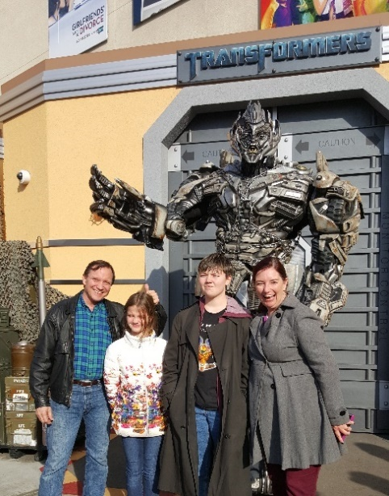
Sinners
I have watched a ton of movies in the last couple of months. I chose three in celebration of the coming summer blockbuster season. These are all very much big-screen films, but much more than big, they are all quite satisfying.
Sinners is one of the best movies I’ve seen in years. Really. Director Ryan Coogler pulls off a very rare trifecta: cinema that uses moviemaking to do things that only movies can do, a genuinely scary monster film, and a eyes-wide-open view of the American black experience. I found myself correspondingly gasping in awe, shrieking in fear, and crying in empathy. Twin brothers with criminal backgrounds and capabilities try to start a legitimate dance hall business in the 1930s South, only to face not only the Klan, but

vampires with a hive mind that love to collect music. I thought I was going to see a reworking of Robert Rodriguez’s From Dusk Till Dawn, but this was so much more. Film schools will be teaching the dance sequence that is the emotional center of the film. Great script, great performances, great music, great direction and cinematography. Highest recommendation to anyone who loves the power of this artform. I will be shocked if this movie does not walk off with major awards.

Mission Impossible – The Final Reckoning
The Mission Impossible franchise is nearly unique in how each new installment gets better than the last. The first film was lackluster and did not bode well for any further episodes. Then the second film was so much better. And then the same happened with the third. By the fourth installment, I was a vocal fan. I love series of films that stand on their own but paint a large arc story. I loved how they managed this with the Daniel Craig Bond films. This last installment wraps up everything from the previous four. They even include references to the previous escapades to catch up viewers, and to remind us that the entire series has taken place over just a few months. The movies are hyped with the outlandish stunts Tom Cruise executes himself, but I almost regret this. The heart of these stories is the relationships within the IM team. It is refreshing to see big action films draw in audiences and then show them stories about loyalty and integrity. The fourth film sets up an ultimate enemy in the form of an unbeatable artificial intelligence that is taking over the world with doomsday intent. The writers had their work cut out to find a way to defeat what in reality would be an insurmountable foe. But they manage it while staying true to the original spirit of the Mission Impossible television series – with slight of hand and edge-of-you-seat timing. Well played and very entertaining.

Thunderbolts – The New Avengers
I am kind of over Marvel superhero movies. The Avengers Thanos arc was so well done that the subsequent installments have looked like squeezing the franchise for money alone. I went to this movie only because I adore what Florence Pugh and David Harbour brought to their roles in Black Widow. What I saw was so much better than I expected. Funny and charming? Yes. But also thoughtful and willing to tackle something that is too often overlooked in the mad rush of superhero films: mental health. The best Frankenstein films have been about the moral and emotional struggles of bringing the dead back to life, not just the horror of creating an out-of-control monster. The best superhero movies have been about the moral choices of how to use superhuman powers. This one asks how to cope with a power that derives from instability. And better yet, confront this with heroes who don’t have world-bending superpowers. Florence Pugh’s Yelena is the centerpost of the team and the story. Her childhood was stolen from her, her sister and best friend has died, she hates that her only skill set has her working as an assassin to kill people she doesn’t care about for the head of the CIA whom she hates. With depression setting in, she faces an enemy whose power derives from and inflicts depression. I won’t say anything more to give away too much, but I was delighted to see her find compassion as a winning superpower.

Have a Drink

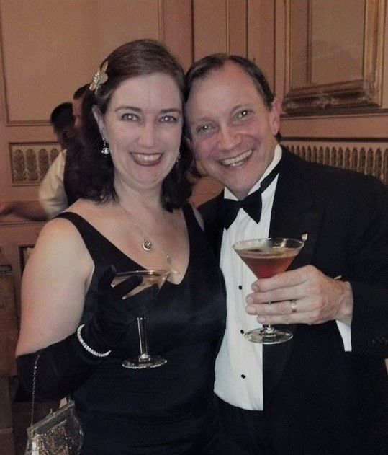
The Two Flowers – An Opera of Ancient Atlantis

I have talked about how this project made me really think about the dangers of cultural appropriation. Originally I set it in ancient Guatemala but I am not Latin. Then I considered lost Lemuria (in the Pacific) but I am not Polynesian. Finally choosing Atlantis, I get to play with Greek musical instruments without annoying modern Greek audiences. Enough musicals and plays have been set using Greek myths without fear of cultural appropriation (e.g., Hadestown). I think I can safely borrow the music reverentially with my vision of the much older Atlantean gods.

Now that I have accidentally teased you multiple times in various issues of this newsletter (sorry), I figure it’s about time I tell you the

story. Here is the first half of the synopsis. The other half will appear in the next issue. The draft libretto is done. The music is not – yet.

Opera sung in English set to traditional Greek/Mediterranean music. Acts are introduced by a walk-on singing quartet of the archeologists who discovered this story in long-sunken ancient carvings. Principal instruments include traditional Greek lyre and drums, with additional guitar, violin, and trumpet. The play requires a large enough stage to support at least a dozen warriors in battle, with two opposing raised areas (box seats) for leaders to oversee battles. Sets include a mountaintop, a couple of palace interiors, a temple, a garden, a jungle, and a battlefield.

Synopsis

In ancient Atlantis, two city-states grudgingly are connected by a wide verdant valley. Kirolos is at the seashore (the blue city) while Thrame is in the mountains (the red city). The two patron gods of these city-states have been forever meddling in human affairs (successions, marriages, births, etc.) and usually to disastrous effect. Belacor is the blue male sea/cloud god of Kirolos. Shimissa is the red female volcanic firebird goddess of Thrame. They are sibling antagonists.

The Principle Cast & Names

Kirolos City Thrame
Belacor God Shimissa
Menkanub King Ygnatim
Chaluna Heir Torron
Quillo General Hoolad
Riappo Priest Lacca
Zupi Servant Pamo

ACT ONE
INTRODUCTION
Archeologist quartet introduces lay of the land and excuses the use of modern music to tell an ancient story. They assumed traditional Greek music was a close approximation, since the carvings didn’t come with sheet music.

SCENE ONE: Mountaintop overlooking the valley
As the story opens, the two cities are on the brink of war. Belacor and Shimissa descend to a mountaintop and dance around one another in an almost combative style. Realizing what a mess they have made of their subjects' lives, they agree and promise one another to stop interfering in human affairs. Their song is built around, “How have I let this come to pass?” In spite of them being brother and sister, they are very touchy and clearly lovers. They can still give counsel to anyone who asks them by name, but there will be no more unsolicited schemes. The scenes between the gods are all in this combative, almost Flamenco style, to demonstrate their high passions, good and bad.

SCENE TWO: Battlefield
As the red Thrame army marches to battle, Belacor takes human form as an old peasant man with a water wagon and curses Ygnatim, the king of Thrame, such that he cannot be resurrected. This, of course, is breaking his promise to Shimissa not to meddle. This while King Ygnatim sings how he will finally “get his revenge.”
The song for this scene is the main theme of the play. It is the principals singing over the soldiers who chant their own rhythm. Think “Do I Want to Know” by Arctic Monkeys or “Kashmir” by Led Zeppelin. When battles start, the soldiers switch to hand clapping and weapon slapping to keep their back beat. The song shifts toward the end to a darker melody or key as things go badly (the kings die in this scene). The song appears two other times during the play. At the end of Act One there is a negotiation scene that also ends badly. And the finale, where the second part is upbeat and triumphant since there is at last a happy ending.
As the battle ensues, the scene and actors shift to the other side of the stage (of the battlefield) where Menkanub, the king of the blue city Kirolos, seeks tactical advice from his god of the sea Belacor, who is currently in human form and does not answer. Menkanub continues the song about finally “getting his revenge.” Menkanub disagrees with the advice from his general Quillo, makes the wrong choice on his own and dies. The audience sees that had Belacor not been meddling, the god would have been there for the king, and the king might not have died.
Shifting back to the other side of the battle, Ygnatim, full of pride and angry with his god, refuses to ask for Shimissa’s help, also disagrees with his general Hoolad, makes a bad choice, and also dies.
Menkanub's second in command, and his successor, is his son Torron. Ygnatim's second in command, and his successor, is his daughter Chaluna. The two regents, at the urging of their generals, call it a draw and the armies retreat to their own cities. As they take over the song from their fallen fathers, the regents sing how “seeking revenge has only led to ruin.”

SCENE THREE: Ygnatim's tomb at the Thrame palace
Shimissa takes human form and goes to Ygnatim's tomb. She sings that he was always headstrong and unwilling to take her counsel, and now he is dead for it. She puts a magical crown on his head to resurrect him. Her sensuous song (she is a red firebird) is built around, “Second chances even if you don’t want them.” The scene is played for dark humor. This, of course, is breaking her promise to Belacor not to meddle. Shimissa leaves. Belacor's curse prevents the resurrection, but the crown does summon Ygnatim's spirit, which appears to his son Torron. Ygnatim tells his son to go to his body and remove the crown, else he remain trapped as a tortured soul. Torron removes it which frees his father to go back to the underworld. Torron suspects the crown may have other powers, so he keeps it. He finishes with a reprise version of “Second chances.”

SCENE FOUR: Jungle clearing at night
Lacca, the high priestess of Shimissa, and Riappo, the high priest of Belacor, meet secretly in the countryside to conspire to end the conflict. Their song is a Tango, and their movements around one another reflect the negotiation nature of Tango. Neither of them trust their respective gods to do anything but further mess things up, so the two strike on a plan to use magic stolen from their gods to affect Torron and Chaluna. Their song is built around, “How do we get back?” In peaceful times, Torron and Chaluna grew up as childhood friends. That all changed when their fathers went to war. The priests’ plan is to rekindle the friendship they used to have by putting spells on Torron's valet Pamo and on Chaluna's handmaiden Zupi, such that whatever happens to the servants emotionally will sympathetically affect the prince and princess. If they can get the servants to fall in love, then the regents will be compelled to overcome their hatred. The priests don’t know how the kings came to hate each other so much. They suspect it is due to how the queens died, but they were mere acolytes back when that happened, and they know no details. They discuss the creation of a magic garden where the two servants can meet.

SCENE FIVE: Kirolos War Room
Chaluna and her general Quillo discuss how her father Menkanub never told her his plans for running a combined kingdom. Even though he was entirely focused on defeating Ygnatim, he still got killed. Quillo says the kings blamed each other for the deaths of their queens. Chaluna sings this just doesn’t feel right, that there is something she doesn’t know that will make all the difference. The song is melancholy, rising to anger in places.

SCENE SIX: The magic garden
Pamo and Zupi both get turned around in a mysterious fog and enter a walled garden from opposite sides. From Pamo's angle, the architecture is that of his red city Thrame. From Zupi's angle, the architecture is that of her blue city Kirolos. Therefore they each think they are still in their home cities. Their clothes are plain enough that neither recognizes the other as from the enemy city. They are each left to assume the other is a new member of his/her court. Their movements around one another are flirtatious, with their hands innocently behind their backs like a courtship dance and they move around facing one way most of the time (so they only see their own city’s architecture). Their song is built around, “It’s easy to get lost.” They greet each other cordially, flirt innocently, and then leave by different exits.

SCENE CHANGE INTERLUDE
The archeologist quartet recaps that the priests' plot is underway and the gods have both broken their promise to one another not to meddle unbidden. Always schemes and lies. No wonder these people are in such trouble.

SCENE SEVEN: Public square in Thrame
Torron addresses a crowd, assuring them they will be victorious over Kirolos. This is his chance to step up and lead his people. He shows off the magical crown, saying it is a gift from Shimissa, proving their goddess’ love and protection. This is his big solo, and centers on “We should rule the whole valley.” The song has lots of proclamations with call backs from the crowd.

SCENE EIGHT: Mountaintop overlooking the valley
Shimissa is wringing her hands worrying about how Torron was seen wearing her magic crown in public, and how Belacor is going to realize she broke her non-meddling promise. She's convinced the resurrection of Ygnatim didn't work because Torron took the crown off his father's head too soon. Her song centers on “I have to protect my secret.” Belacor arrives on her mountaintop and accuses her of using the crown. Again, their movements are Flamenco, circling and trying to out-position one another. Shimissa says Prince Torron stole the crown from her, and that she is going to take it back. The song shifts to the two of them singing “We still have no secrets.” The two gods swear they haven't meddled and they reiterate their promise not to. (Since they have both broken this promise, now they are both lying.)

SCENE NINE: Thrame courtyard
Pamo asks Torron who the new handmaiden in court is, and Torron doesn't know. Torron sings with sweet melancholy about how lucky his valet is to have found someone at his own station, and how Pamo “barely knows what he’s doing, and it's lonely at the top.” The only woman at his station is Princess Chaluna, and she is his enemy. Pamo asks Torron about going to war. Again the song turns on him “barely knowing what he’s doing, and it’s lonely at the top.” Torron is rather shocked at how blindly the crowd was willing to follow his forceful rhetoric. This is a typical opera conversation set to music.

SCENE TEN: The battlefield
The two regents meet out on their border to negotiate. Both show leadership and savvy, and they take the counsel of their generals (unlike their fathers) but talks break down and war seems certain. Their negotiation is in pantomime while the generals sing. This is the second appearance of the main theme song. The generals each sing they know the other’s tactics, since they used to train together before the kings went to war. They sing over the background beat of the soldiers chanting. The generals also sing they know the kings went to war blaming the other for the death of their queens. Since no one has been allowed to talk to the other court since war was declared, suspicion and distrust have grown. Their song is “What we don’t know.” It forms the first phase of a three phase song.
The gods watch the meeting, and Belacor asks Shimissa if it is safe to let the regents meet face to face. Shimissa says the forgetfulness spell their fathers made the gods put on the children is plenty strong enough to hold up against a simple meeting like this. The fathers went to their graves not forgiving each other for the deaths of their wives, so the gods feel compelled to keep the fathers’ spells intact. They allude to how the gods had in fact suggested the spell, but they refuse to take the blame for its consequences. Their song is built around, “If they only knew.” This rolls in behind the generals singing “What we don’t know.”
The song then shifts to the darker melody, showing how this is ending badly. While the courts are together, the two high priests meet in private. They are shocked the two regents don’t seem to even recognize each other from their childhoods. They sing “How could they not know?” which rolls right in behind the gods singing “If only they knew.” The priests agree they must speed up their plan if they are going to head off bloodshed.

INTERMISSION



That’s it for this edition. I hope you enjoyed it. Please invite your friends to sign up. I am actively generating content as I never have before. This newsletter is the best place, and in some cases the only place, to hear about it all ahead of publication.

Until next issue, be well!

