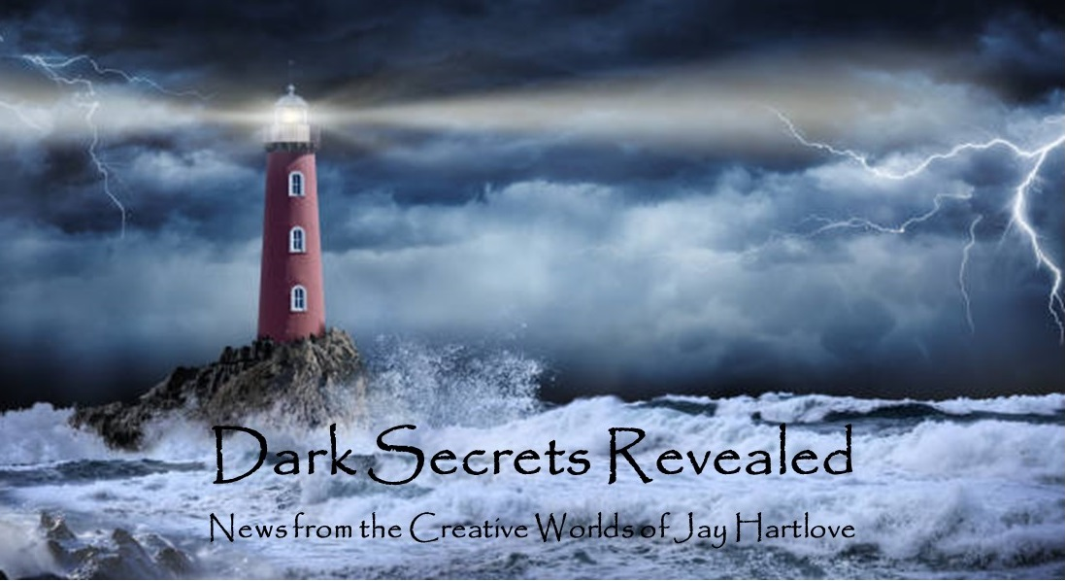
Issue 32 July 2026
More good news this issue. The sequel to The Dove and the Crow, called Sins of the Father, is now with my Beta Readers for critique. I am signed up to be on four panels at Worldcon in Los Angeles in late August. Baycon was a blast. And my publisher is running The Dove and the Crow through production line edits. I discuss all of these and more below.
I put all the back issues of this newsletter up in an archive on my website www.jaywrites.com. Check them out if you joined late and missed some editions.
I would very much like your feedback on this newsletter. Please feel free to write me at jay.hartlove@gmail.com and let me know your thoughts. This newsletter is for you. I could set it up as a sales tool, with lots of buy links, but that’s not why I write it. I do this to share my work and insights with you.
Also, please let me know what you thought of Goddess Revealed. Did you find it interesting? Did it make you want to go back and read the trilogy? Do you think it is a good incentive to sign up for this newsletter?
Here are the usual newsletter columns:
- What’s Cooking: Previews/discussion of what I am actively working on. Also links to interviews, appearances, and other current writing news.
- Mister Wizard: Advice and analysis to help my fellow writers.
- The Aisle Seat: Recommendations. I am a huge movie fan and watch several every month.
- Have a Drink: Wherein I will share personal stories.

What’s Cooking

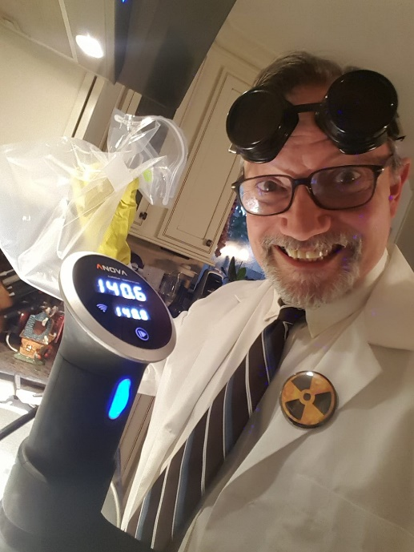
Sins of the Father is Out for Critique
Last month I told you that I had finished the first draft of the next book in the Hern series. I started to run out of new ideas to put into the book at about 75,500 words. I sent it to my critique circle and they are reading is now. We will meet in mid-August for their feedback. I asked them what is missing, what they would want to see more of, or what they thought was unnecessary. A content review.
Since I gave it to them I found a few places where I should hav said a little more. The draft is now at 76.500 words and 297 pages. I will let you know next month what the beta readers say.
When I told them I had the next book ready for them, one of them said, "Good grief, man, when do you sleep?" It is a bit misleading. I waited until I had finished, pitched, edited, and run the first book through multiple rounds before I showed it to them for polish edits. During the year of that process, I wrote the next book. This one is hot off the printer, at the beginning of what will be a year-long process. So yeah, they look back-to-back. No, it really takes me a year of more to draft a book.
I did not adopt an inspirational song of this book. This is highly unusual for me and I don't know why. The plot is driven by the urgency of the giant invasion, and then redoubled with Naomi's race to rescue Willa from the underworld. So there is a lot driving the action. If that regard, the book is probably closer to my thrillers where one crisis comes on the heels of another. The songs I pick usually help me feel what key characters feel. The two songs I picked for The Dove and the Crow were clearly aligned to Naomi and Willa and their emotional needs. We meet many new characters in this sequel, but none that needed a song to center my thinking.
I am highly amused that I am working on these books, and they will be coming out, in the midst of the public's fascination the Chris Nolan's new film The Odyssey. Hern's magic derives from the presence of their gods who are parallels of Earth's Greek gods. And the first story Willa tells in the pub of her adopted town is in fact The Odyssey. (After all, it is a story about trying to get home.) I planned this years ago, long before I knew of the movie. Maybe I will get some lift from the zeitgeist. We will certainly be citing the subject in the advertising. Wish me luck!
Since this is a subject close to my heart, I will of course talk about the film below in the movie recommendations section.

Mister Wizard

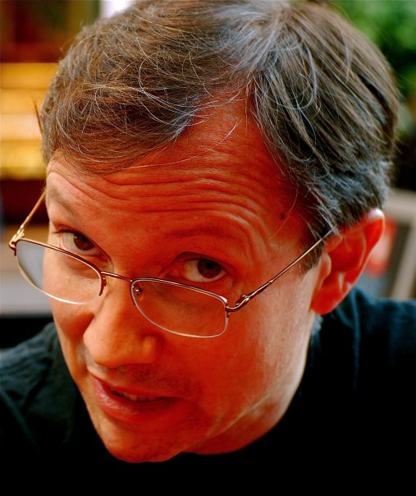
Upcoming Convention Panel Appearances
LA Con V, the 84th World Science Fiction Convention, has confirmed I will be on four panels. I am waiting word on whether they will give me a room slot to do a reading. Four panels is a big deal. My publisher asked me to ramp up my visibility this year before the book release. I was on six panels at Baycon, which his a major regional convention. But this is WorldCon. I have also applied to be on panels at the World Fantasy Convention in Oakland, California in October. My WorldCon panels are as follows:
How to Change Your Writing Process - When Panters have to Outline
Thursday, August 27, 2026 at 6:00 PM
You've pitched a project to an editor who is interested. Yay! But. They want to see an outline. You're a pantser! You like letting the story evolve through experimental writing! What are you going to do? Our panelists are those who outline plus those who usually don't outline but have learned to as they discuss strategies for developing an outline: How to keep the idea fresh in your mind, how to approach structure, how to infuse the outline with the passion you feel when pantsing the story, etc.
Fracturing Fairy Tales
Sunday, August 30, 2026 at 6:00 PM
Whether fairy tales are ancient stories collected over the centuries, magical stories fabulated by a single author, or tales and traditions about the elusive beings who drift in and out of our world, all are a fertile field for reinvention. Let's talk about how and why we "fracture" fairy tales, offer examples, and how these in turn inspire new streams in the ever-changing river of literature Beyond the Fields We Know.
Swords and Slow Burns: Closed Door Romantasy
Monday, August 31, 2026 at 9:00 AM
Whether the romance is front and center or side plot, less spicy stories are blossoming in fantasy. Whether your characters care less about sex or are just cautious about jumping in the sack, sex doesn't have to be in your face. Explore how authors are navigating the increasing demand for these slower burn romances.
Trauma vs. Entertainment
Monday, August 31, 2026 at Noon
Scary stories distract us from the horrors of the world, and also help us process them. Writing and art are channels for the creator's trauma as well as the audience's, and also joyful distractions from it. Is there a line between entertainment and real trauma? What about the popularity of the True Crime genre? How dark is too dark?

The Aisle Seat
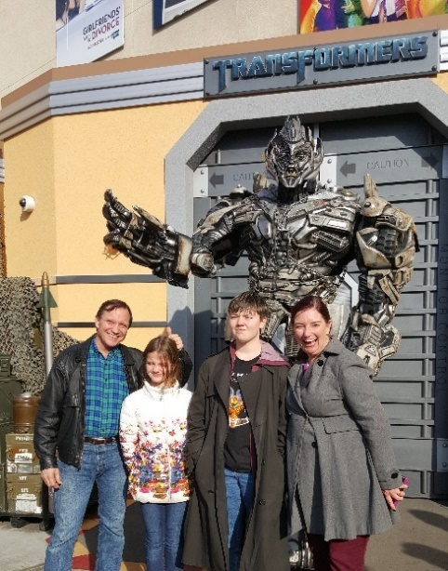
The Odyssey
I'm only going to talk about this one movie this time. Since this story plays such an important role in The Dove and the Crow, I have a few things to say about it.
Unless you have been lost at sea all summer, you will have seen and heard a lot about this movie. I will limit my observations to three points: 1) Nolan is a master of his craft. 2) Retelling a tale should include the storyteller's own choices. And 3) haters gonna hate. First of all, I loved it. Go see it on the biggest screen available. It is a rare and delicious feast of a film. Now to my points.
Christopher Nolan made some bold choices. He always does. He challenges audiences to keep up. Many vocal people disagree with some of his choices. I loved what he did here. His choice of what to show and what not to show is what cinema is all about. What he doesn't show makes what he does show ever more impactful. Without too many spoilers, his choice of Zendaya to play Athena initially seems odd, only to have the reason drop like a bomb in the third act. He chose not to let us hear the siren song, but rather to show what mattered was its lasting impact on Odysseus. His choice to never show us Agamemnon's face reduced him to the icon of ambition he needed to be in this telling of the story. There is some amazing camera work. Very little CGI was used, and mostly just to clean up images captured from practical in-camera visuals. The use of puppets and forced perspective will be taught in film school for years to come.
Making choices is why filmmaking is an art. There was s time when painting to exactly reproduce what things look like in real life was fascinating. But even then, the most appreciated realism paintings added the artist's unique interpretation and choices of color palate and lighting. If studios give $250 million to a director to film a 12,000 line poem written thousands of years ago about fictional events, I want to see what that director brings to the story. Nolan chose to adopt much of the recent and fairly feminist translation by Emily Watson. This gave him a clearer view of important female characters like Penelope, Helen, Calypso, and Circe.
Which sadly brings me to the last point, that haters gonna hate. Emily Watson just came out with a scathing critique of the film. She didn't like a lot of the choices Nolan made. When she published her book In 2017 she said she only expected to sell a thousand copies. Due to the film's popularity, her book just topped one million sales. I'm afraid we have a Saving Mr. Banks problem. Pamela (P. L.) Travers wrote the Mary Poppins series of books. When Walt Disney approached her to make the film, she hated almost every decision he made, including the music and the dancing, and especially the mixing of animation into the movie. Disney went ahead and made his movie, thinking he was staying true to the source material, despite the author's objection. Of course the movie was a huge success. Ms. Travers never relented. Director John Hancock made a perfectly charming movie in 2013 of this conflict called Saving Mr. Banks starring Emma Thompson and Tom Hanks. The stories were too precious for Ms. Travers to appreciate any outside interpretation. That appears to the same case with Ms. Watson. Movies made from books are easy targets for the book lovers to criticize. That doesn't even apply here. Nolan did not make a movie of her book. He made a movie to bring out what he felt is relevant today from this ancient tale. His commentaries on loyalty, the damage war leaves on people, how pleasure can steal time, and the value of decency in a civilized society are much more valuable than putting Homer's text accurately on the screen.

Have a Drink

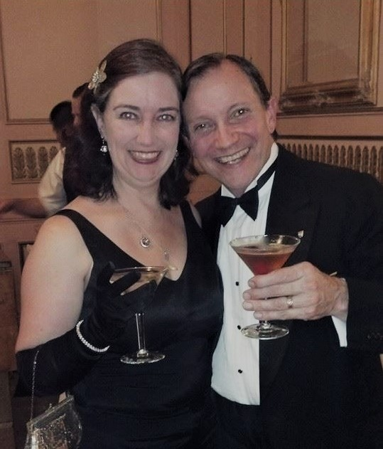
Baycon Report

Baycon 42 was a lot of fun. I spoke on seven panels, including my seminar on how to get unstuck and finish writing a novel. Here is a quick recap of the other six.
Do Possible Futures Evolutionarily Diverge, Converge, or Both?
The panel talked about how AI might fit into the evolution of humankind. There was conjecture about the rising incidence of autism possibly being a sign of the gene pool getting ready to adapt again. I said the next step for human evolution would be to adapt to conditions that made the world uninhabitable for the current batch of humans. I once wrote an article that was published in an
Episcopalian blog about twenty-five years ago entitled, "An Intermediate Form Looks Forward to His Replacement."
Writer’s Workshop
The workshop was well attended. We had seven coaches and six entrants. We divided into two groups and had much lively discussion of submitted stories. The entrants all came away happy with the feedback.
Genre Fiction as the Fiction of Hope
This was a panel I suggested. Several very thoughtful writers including the Guests of Honor Charlie Jane Anders and Annalee Newitz joined the panel. This was s high point of the con for me. We talked about how in fiction the protagonist gets to make a difference which rarely happens in real life. We talked about how depressing times spawned surges in genre fiction. Examples were the rise of comics in the Great Depression, the rise of Fantasy during the Vietnam War, and the rise of superhero movies after 9/11.
Starting Your Writing Career in Midlife
Two writers in their forties joined two writers in their late 60s and early 70s to talk about how it's never too late to start a writing career. Sometimes life sidetracks you for decades until you finally find space to get serious about writing. Thankfully, none of us have been blocked by ageism in the industry..
Folklore is Your Friend
We talked about how giving your worlds lots of history and giving your characters lots of life experience and knowledge about their world's history gives and author fertile ground to grow stories that pull readers in. We also tried to define the difference between history and folklore.
Self-Editing Strategies
We talked about the value of getting and listening to feedback. I said I write in iterative waves that expand a story as I think of new things. That also gives me time to really see what I've written and fix mistakes as I go. Some of the panelists prefer to write the first draft with no regard to editing just to get it done. We all agreed you can't edit a blank page, that something written is always better than nothing.
How to Finish a Novel
This was my big moment to shine and I think it went well. I gave this seminar ten years ago at Baycon to a standing-room-only crowd. The convention scheduled this session on Monday morning, the last day of the con. Many folks left after Sunday night, and the crowds visibly thinned Monday. Still I had 27 folks attend. They were all enthusiastic and asked good questions afterwards. 37 slides with an hour of instruction.
I had a surprise guest speaker. The convention let panelists request to be added to panels on the scheduling software. This was a great feature. It was how I got Charlie Jane and Annalee on my Hope panel. Fabled science fiction author Larry Niven invited himself onto this panel. He wanted to share amusing stories about how he had gotten stuck on books. I explained this was a seminar and not an open discussion panel, and I invited him to take over at the end of my presentation. He agreed, and we all got to hear some great stories about his days collaborating with Jerry Pournelle on such books as Lucifer's Hammer and The Mote in God's Eye.
I taped the session. Several attendees said they were too focused on the presentation to take good notes and they asked me to post the tape. The sound quality is pretty poor. I am seriously considering filming this as a lecture in a studio setting. I will keep you posted if I do that. In the meantime, here is the link to the convention tape. https://youtu.be/HKFZsrziAg8?si=eW4uRHAF58nv55ZE

https://youtu.be/HKFZsrziAg8?si=eW4uRHAF58nv55ZE

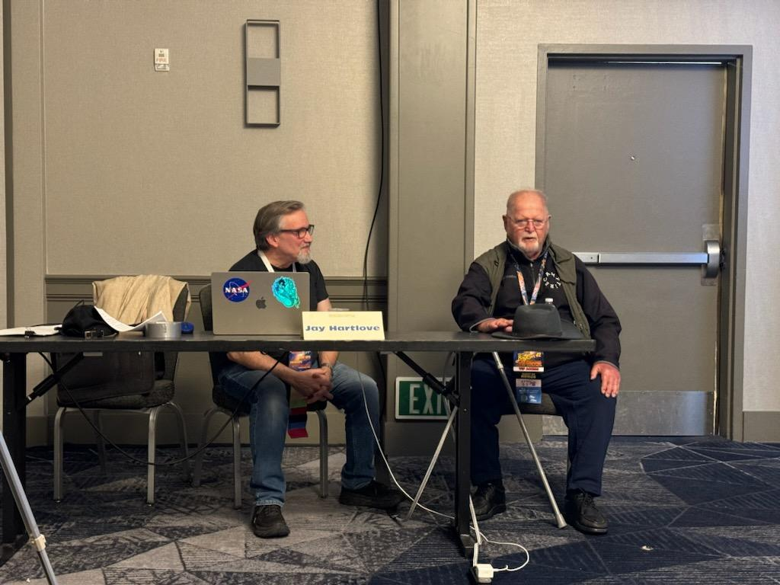

Photo credit Cliff Winnig

That’s it for this edition. I hope you enjoyed it. Please invite your friends to sign up. I am actively generating content as I never have before. This newsletter is the best place, and in some cases the only place, to hear about it all ahead of publication.

Until next issue, be well!

