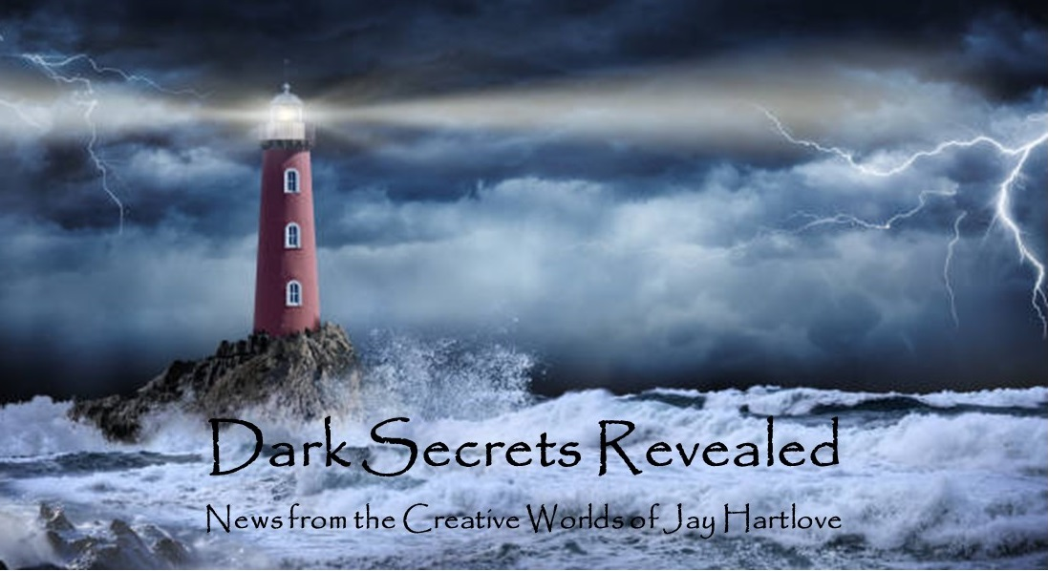
Issue 31 June 2026
Lots of good news this issue. The Dove and the Crow is now in final edits at the publisher. I completed the sequel Sins of the Father. I’ve started a new book. I am on multiple panels at upcoming conventions. The mermaid convention this year was lots of fun, as it always is. Selling my mermaid fantasy romance to actual mermaids is cool. I landed my first social media influencer. Things are looking up.
I put all the back issues of this newsletter up in an archive on my website www.jaywrites.com. Check them out if you joined late and missed some editions.
I would very much like your feedback on this newsletter. Please feel free to write me at jay.hartlove@gmail.com and let me know your thoughts. This newsletter is for you. I could set it up as a sales tool, with lots of buy links, but that’s not why I write it. I do this to share my work and insights with you.
Also, please let me know what you thought of Goddess Revealed. Did you find it interesting? Did it make you want to go back and read the trilogy? Do you think it is a good incentive to sign up for this newsletter?
Here are the usual newsletter columns:
- What’s Cooking: Previews/discussion of what I am actively working on. Also links to interviews, appearances, and other current writing news.
- Mister Wizard: Advice and analysis to help my fellow writers.
- The Aisle Seat: Recommendations. I am a huge movie fan and watch several every month.
- Have a Drink: Wherein I will share personal stories.

What’s Cooking

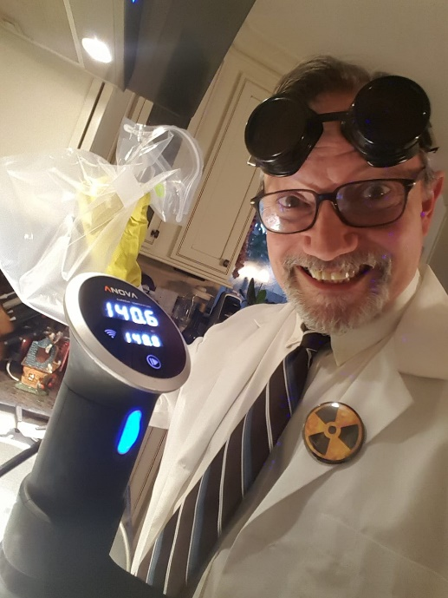
The Dove and the Crow in in final edits
I can finally announce The Dove and the Crow has been bought by Matthew James Publishing, a division of Archer UK, a one-hundred year old small press in London. The book is now in final edits and it is slated to be released in Spring 2027.
The area of the alternate world Hern where the story is set mirrors the geography of northern Italy and southern Switzerland. Willa arrives in the country of Brunia, and the language they speak is an amalgam of German and French. So the book has a Eurocentric focus. I am hoping an English publisher will reach the European audience more effectively.
Archer waits until they have a final cover before they make their official acquisition announcement. That is usually four to six months
before publication. That window gives professional review channels time to assess the book. So expect the cover reveal at the same time as the announcement and the availability of ARCs for review in the November time period.
It was a year ago that I sent the book to an independent editor in England. She loved it and referred me to Matthew James. In that intervening year I have written the sequel, Sins of the Father. At a dinner with writers some months ago, a friend asked what do you do when you’re waiting for agents/editors/publishers/gatekeepers to decide to accept or reject your book. His mentor was at the table, and she hesitated to give him a simple answer. I said he should work on the sequel. Have faith in your first book and forge ahead with the next one. I have taken my own advice.
The first book is about a woman who is thrown into another world and must start her life over. The new world has magic which she sees as an opportunity to take chances and make a difference. She was ignored and belittled in her old life. The story is about stepping up given a new chance. People fantasize about leaving their life for a better one. If you were given such a new start, would you step up to take full advantage?
The second book is now done. As of the last newsletter, the first draft came in at 250 pages. I knew it was light on descriptions due to my rushing to figure out the ending. The finaI draft is 292 pages. I will be giving it to my beta readers next weekend when I see them at Baycon. This book drills down how her father mistreated her and left her chasing self-centered men, still trying to please her father. This background leads her to make overreaching assumptions about the motives of a dead god, and the consequences of projecting her own trauma. The back cover blurb reads:
Willa and Naomi must unravel the mystery of a long dead god before a race of giants destroys the cities of Hern. Dark secrets are unveiled, both about Hern’s legacy and Willa’s past. Willa’s lingering resentment for her father leads her to disastrous assumptions that threaten the balance of magical power. Travelling across the continent and all the way to the underworld, can Naomi help Willa find the forgiveness she needs to break a generational cycle of godly cruelty?
This book has a lot more action than the first. The first had a lot of world building to cover which slowed things down more than my usual thriller pace. This one is back with more Sinbad style adventure, including an Orpheus and Eurydice hunt through the underworld land of the dead.
I have a plan for the third and final book called Nobody’s Child. Yes, it too explores family and generational trauma. Matthew James has not committed to buying any sequels. These books do not fit neatly into any market category. My books never have. I fully understand that they want to see how the first book is received before committing further.

Mister Wizard

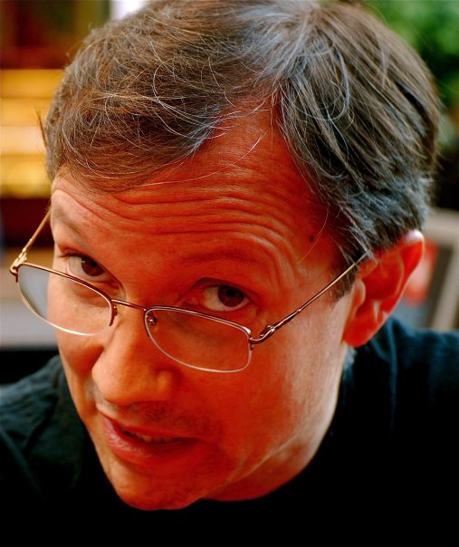
Upcoming Convention Panel Appearances
I applied to run panels at Baycon in San Jose in July, WorldCon in Los Angeles in August, and World Fantasy in Oakland in October. I requested the same panels for all the conventions, figuring some would be accepted by some shows but not others. As of this publication date, only Baycon has completed their schedule.
Baycon is running their programming in a most user-friendly fashion. They took suggestions, put together a preliminary schedule which they showed to the participants. We could then invite others onto our panels. As a result, I have ended up on a full schedule which includes ones I would not have thought of myself. This is going to be a really fun show. Here is my schedule:
Do Possible Futures Evolutionarily Diverge, Converge, or Both?
Friday, July 3, 2026, 4:45 PM - 6:00 PM
Despite different origins, after a billion years or so, are intelligent species more or less alike? Will common technology, like Gen AI, pan-species translators, and high-speed travel tech lead to common cultures and increasing lack differences between cultures. What are some examples of this in fiction and nonfiction?
Writer’s Workshop
Saturday, July 4, 2026, 10:30 AM – 11:15 PM
I am on a panel of writing coaches who will give critiques of stories submitted by fans. I have done this several times and it is always an affirming experience. Thank you, Dr. Wanda Kurtzu for continuing to sponsor this event.
Genre Fiction as the Fiction of Hope
Saturday, July 4, 2026, 11:30 AM - 12:45 PM
In troubling times, fiction offers a much needed escape. Genre fiction offers something more. In Science Fiction and Fantasy stories, the protagonists make a difference. A satisfying genre ending almost always includes righting a wrong, vanquishing a foe, or otherwise leaving the world a better place. Real life rarely offers the opportunity to make a real difference in our world, especially when the real world is in turmoil. This is not only true today, but it was true during the times when genre fiction flourished in the past, such as the Great Depression (which saw the rise of Science Fiction and comics) and the Vietnam War (which saw the rise of Fantasy). Panelists will discuss the historical timing and the optimism genre fiction brings to today's readers.
(I suggested this panel and several luminaries have joined the panel. I’m very excited about this one.)
42 The Author: Starting Your Writing Career in Midlife
Saturday, July 4, 2026, 2:15 PM - 3:30 PM
MAIN STAGE: Many authors started their careers later in life. Toni Morrison was 39 years old when she published her first novel, The Bluest Eye. J.R.R. Tolkien was 45 when he published The Hobbit. Alex Haley published The Autobiography of Malcolm X in his mid-40s. Richard Adams was 52 when he published his debut novel, Watership Down. BayCon’s own Poet Laureate, two-time Bram Stoker Award®-nominated Sumiko Saulson, was in their Answer Year ~ 42 years old ~ when they started what would become their first completed novel, Solitude, and 44 when it was published. Join Sumiko and other authors who got their start in midlife to talk about why so many start their writing careers then, what to expect as a new author in your midlife, tips & tricks for balancing one’s obligations and the reality of midlife with your writing, and how it’s different from starting out younger (or older!) Come to beat back the demons of self-doubt, to get a babelfish in your ear translating this new-to-you industry, to learn how to pull from your unique perspective at the fulcrum of your life, or to discuss the ways ageism shows up in publishing.
Folklore is Your Friend
Sunday, July 5, 2026, 11:30 AM - 12:45 PM

Worldbuilding is more than terraforming and ecosystems. The little details that are woven throughout daily life add depth and meaning to fictional worlds. How to create the stories behind the legends and superstitions in your characters' lives.

Tea Magic & the Ritual of an Every Day Brewing

Sunday, July 5, 2026, 2:15 PM - 3:30 PM
Join Jenay the tea with behind Kitchen Witch Gourmet for an enchanting conversation about the parallels between a simple cup of tea and intentional magic. From herbs and blends, to ritual, intuition, and every day self care. This panel explores how brewing tea can become a convenient doorway into mindfulness, manifestation, and a little Kitchen witchery- one cup at a time, transforming the mundane cup of tea into a magical Tea Cup Cauldron.
How to Finish a Novel
Monday, July 6, 2026, 10:00 AM - 11:15 AM
Award-winning author Jay Hartlove shares his tips on how to finish that novel you've been working on. Jay gave this seminar ten years ago here at Baycon to a standing-room-only audience. The talk includes such tools as writing the cover blurb to be the mission statement, letting your characters help you tell their story, and how to keep your hand out of the reader's view. Come take notes!
Self-Editing Strategies
Monday, July 6, 2026, 2:15 PM - 3:30 PM
You wrote the book! That’s great. Now what are the quick little tricks to fix it up? What should find-replace do and what needs human eyeballs? What about pacing, word choice, showing vs telling–and how can you tell? And what’s that pesky difference between that and which anyway? A panel of authors, editors, and self-publishers will share their checklists and answer all your questions.

The Aisle Seat
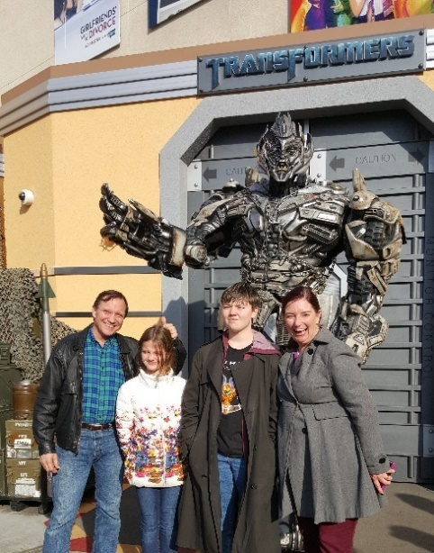
Hamnet
Even though there are studio mergers and other business moves that threaten creative production in Hollywood, this spring has put out a lot of good movies. I considered reviewing a trio of the fun violent ones, namely “Here I Come,” “Normal,” and “They Will Kill You.” I am a big fan of Samara Weaving, Bob Odenkirk, and Zazie Beetz, and these films give the audience just what they came for. Lots of explosions, gunfire, and stage blood. See them if you have that itch to scratch. Today I’m going to dive into three films that made me glad to go to the movies.
Hamnet came out at the end of last year, but we did not see it in the theater. We knew this one was a tearjerker and we didn’t want to make a scene in public. On the surface is appears to be the story of how the death of Shakespeare’s son inspired him to write Hamlet. That happens, but that’s not what the story of about.
It is told from the viewpoint of his wife Agnes, played brilliantly by Jessie Buckley who won the Academy Award for this performance. When the son dies, Will (played very convincingly by Paul Mescal) sequesters himself at the theater, coping with his grief in work. But this leaves his wife to cope with her grief alone while raising their other children. Everyone processes grief differently, but Will disappearing and not supporting his wife, the mother of the dead child, seems like a dick move. But she perseveres. And we live that with her. The payoff, without giving away the ending, is pure cinema. The final sequence marries camerawork, actors laying it all on the line, music, timing, it’s just as good as it gets. It made me thankful for the artform. What starts out as a film about grief ends as a film about forgiveness.

Project Hail Mary
Hidden inside this sprawling spectacle of a science fiction movie is gem about bravery and generosity. For most of the film, Ryan Gosling is acting alone with the alien Rocky (and his puppeteer James Ortiz). As good as the puppetry is, Gosling, as the human we can relate to, gives us all the emotional context. This is a lot of movie for one (or two) actors to carry. We know from the onset that this is a one-way mission to save the planet, but he starts out with an enthusiastic crew. Once he is alone, that finality sinks in. He focuses on establishing a working relationship with an alien who is on the same mission for his planet. The bond they form despite their significant differences reinforces the urgency of their work. Solving the space virus problem is a McGuffin. The story is about how they end up saving each other.

Discovery Day
Steven Spielberg has given us a gift of hope. He has played with aliens in three other films, ET the Extraterrestrial, Close Encounters of the Third Kind, and Super 8, for which he produced but worked closely with Director JJ Abrams. The first two were optimistic about alien contact, while the third copped out as to how violent the creature really was. Here he puts mankind at the brink of self-destruction as we discover that the little gray men really have been here all along. Before I go on, I want to be clear this is a very well-made movie. The camera work and action sequences and pacing and dialogue are absolutely top notch. He postulates that discovering that we are not alone in the universe will make people stop fighting each other and appreciate that we are part of a larger galactic community. I have heard some say they thought this is naïve. Personally, I thought he played very close to a storytelling trap called the Magical Negro (look it up). The oppressed man turns out to be much more capable that everyone thought, including how he forgives his oppressors and makes them regret their actions. We’ve imprisoned the alien astronauts for decades yet they aren’t mad at us and are happy to help once we free them. That means they are not just peaceful, but angelically forgiving. That’s a stretch. But I appreciate that this master filmmaker felt the need to give us hope that something could save us from ourselves.

Have a Drink

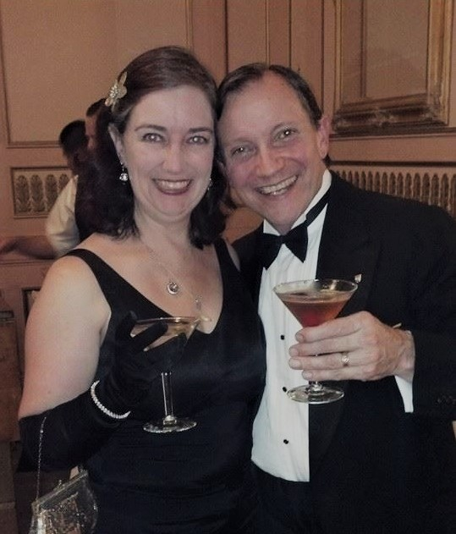
The Price

In several issues of this newsletter over the last year, I have mentioned how my concerns about our world have hindered my creativity. My guiding light has been to write stories that show my readers what normal life is supposed to look like. There is already a lot of dystopian fiction out there. Frankly, I do not envy those writers, as they watch their predictions of near-future awfulness get swamped by much worse in the real world. No, I’ve spent the last two years writing about people getting second chances and growing out of past trauma.
On the other hand, I wrote a story treatment years ago that I envisioned as a twelve part comic called The Price. It is a Space

Opera, meaning lots of action and derring-do with spaceships, aliens, and high-tech weapons. Except this one is really about ending slavery and accepting fate’s role for you. Are you surprised one of my stories has literary themes hidden behind a commercial façade?

It tells the story of a privileged man who uncovers the terrible secret, who trades his wealth for a chance to right that wrong. The premise is that mankind never cracked the self-aware AI puzzle, and was only able to make autonomous androids by implanting souls stolen from prisoners. They’ve even started a war to create more victims to drain. Our hero Cedrick figures this out and decides not to turn a blind eye, even though the economy of spacefaring humanity depends on the androids. The rich will do anything to stop him.



Each chapter is told in first person by a different person who sees him in unique ways as he fights his way across the galaxy. They see him as a criminal, a savior, a scoundrel, a dreamer. Only the last chapter is told from his point of view.

He comes from the Hindu tradition which raised him to mind his karma. When he finally finds a way to shut down the conspiracy, he faces the same choice that his teachings showed: if you could make a real difference between right and wrong, even if it means murder and risking your own karma, would you?

I have been sitting on this story for years. I once discussed possible art designs with an illustrator. My friend Doselle Young, who has written comics for DC, Wildstorm, and indy comics said he could see it as a comic series if I cut it down or combined it into six issues. At the end of the day I am a novelist. I am writing it in prose.

I moved this story to the front creative burner when I saw that it is the stick-it-to-the-man story I have been waiting to tell. In the chapter where our heroes learn the history of the 21st Century, I lay blame squarely on the oligarchs who are currently burning down the Earth chasing AI. And yes, Cedrick decides to follow in Arjuna’s footsteps after Krishna told him to go ahead and kill his enemies (look it up: 2.4: Bhagavad Gita).

I am 60 pages in with a complete outline so far. More to come.

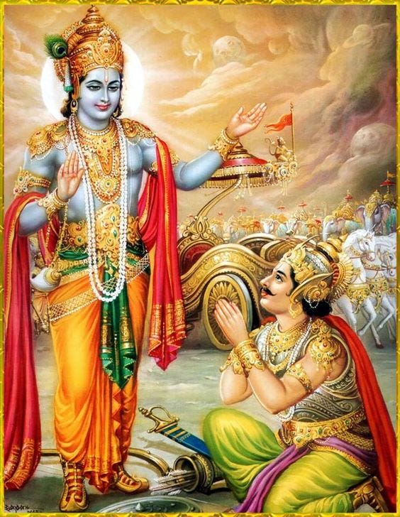

That’s it for this edition. I hope you enjoyed it. Please invite your friends to sign up. I am actively generating content as I never have before. This newsletter is the best place, and in some cases the only place, to hear about it all ahead of publication.

Until next issue, be well!

